

Children First
The AAE Curriculum

Cycle 1
Term: Spring 2

Topic: Food

Spring 2  Topic: Food  Communication Focus: Choosing | WEEK 1  Week Beg:  22.02.27 | WEEK 2  Week Beg:  01.03.27 | WEEK 3  Week Beg:  08.03.27 | WEEK 4  Week Beg:  15.03.27 | WEEK 5  Week Beg:  22.03.27
Maths  Number & Counting | Number formation (sensory) | Number formation  (sensory/mark making) | Matching numbers to 5 using manipulatives (topic link counting) | Matching to 5 using visuals (topic link counting) | Ordering visuals/manipulatives to 5
Literacy/Communication  Focus: Matching | Vocabulary from the focus story | Key parts of the focus story | Matching - using real life fruits to symbols | Matching - symbols to symbols | Matching fruits to descriptions
Science  Healthy Eating | I am learning the names of fruits | I am learning to identify different fruits | I am learning the names of vegetables | I am learning to identify different vegetables | I am learning to sort foods that are healthy and unhealthy
UTW: Geography/RE  Food from different countries & cultures | I am learning about the food from France  Matching task | I am learning about the food from America  Matching task | I am learning about the food from Mexico  Matching task | I am learning about the food from the United Kingdom  Matching task | I can find the country my favourite food is from  Matching task
PSHE  Healthy Living | I am learning which foods keep the body healthy | I am learning that movement keeps the body healthy | I am learning how to keep my body clean | I am learning how to keep my body calm | I am learning to keep my body healthy
Art  Collage | I am learning to rip pieces of tissue paper to make a collage  Children to choose a fruit each week | I am learning to rip pieces of paper to make a collage  Children to choose a fruit each week | I am learning to use glue carefully to stick when  Children to choose a fruit each week | I am learning to use glue carefully to stick when collaging  Children to choose a fruit each week | I am learning to cover the whole picture when collaging  Children to choose a fruit each week
Fine Motor  Cutting with a knife  (Blunt/toy knife)  Example of what to cut each week | I am learning to hold a knife in the correct way Playdough | I am learning to hold a knife in the correct way Playdough | I am learning to apply pressure when using a knife to cut Bananas | I am learning to move the knife back and forward to cut Bananas | I am learning to use a knife safely.  Bread
Gross Motor  Exercises | I can choose an exercise | I can choose an exercise | I can choose an exercise for up to 30 seconds | I can choose an exercise for up to 1 minute | I can choose an exercise for a friend
PE  Dance | Imitate single movements. | Choose another child to dance alongside. | Follow and imitate simple sequences and patterns. | Imitate a 2-step sequence. | I can choose a song to dance to
PfA  Eating and Feeding | I am learning to hold a spoon and use the scoop action | I am learning to use a spoon to feed myself | I am learning to use a fork to pierce food | I am learning to use a fork to feed myself | To choose a fork or spoon when eating my lunch
Life skills  Washing hands | I am learning to turn the tap on to run water | I am learning to add soap and rub my hands together | I am learning to wash off the soap off and dry my hands | I am learning to order the steps to washing hands | I am learning to wash my hands independently
Cooking (optional) | Cucumber caterpillars | Cutting banana | Cutting apples | Cutting melon | Fruit Kebabs
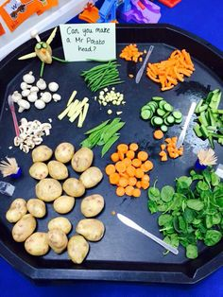
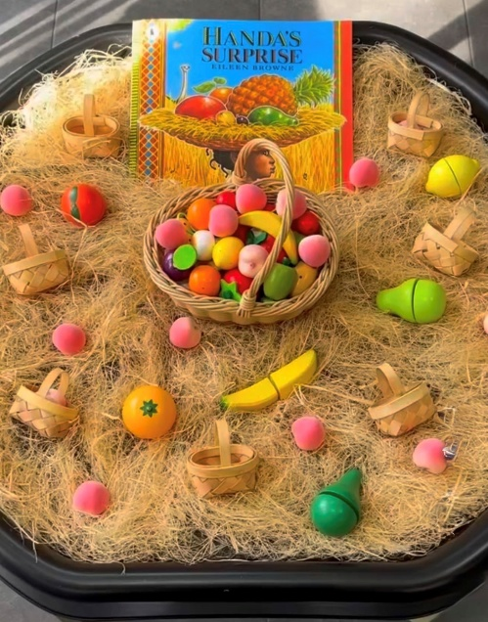
Continuous Provision Resources
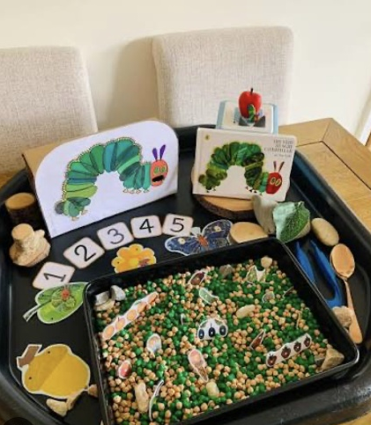
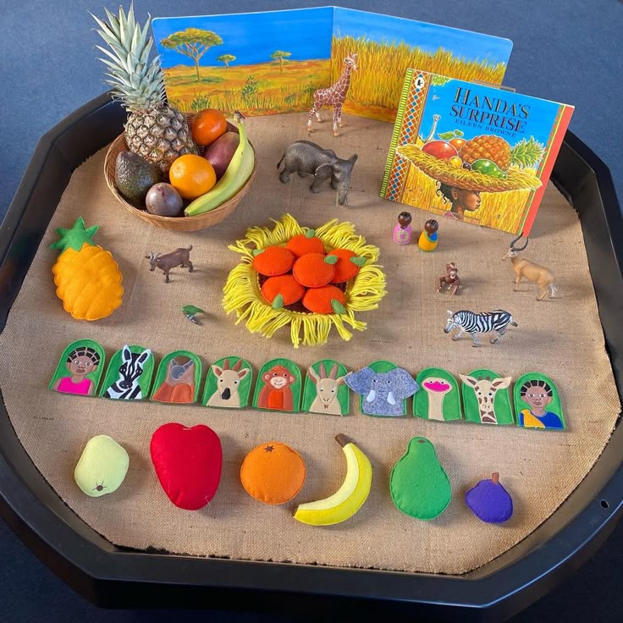

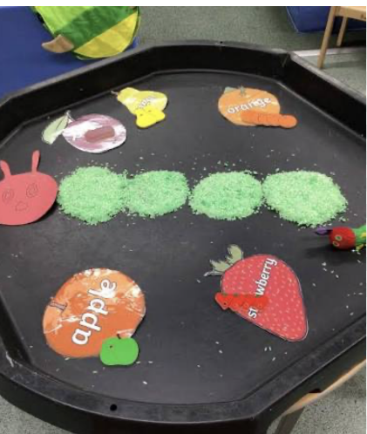
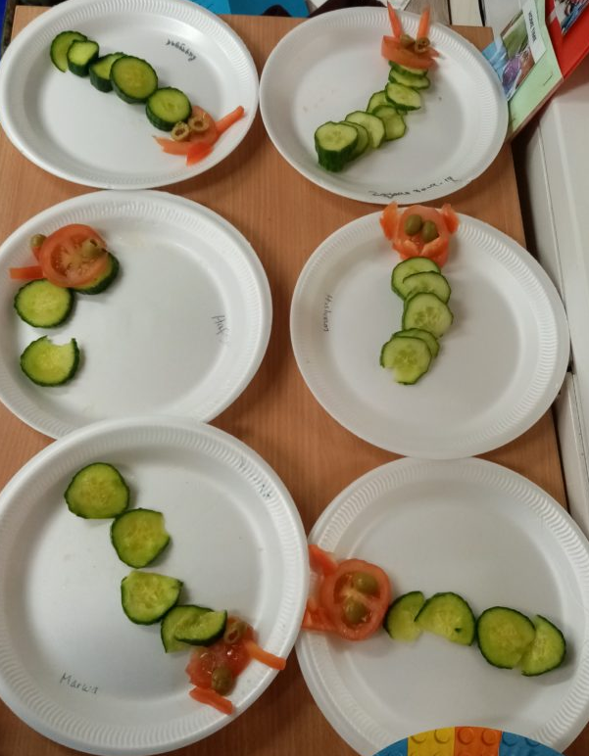
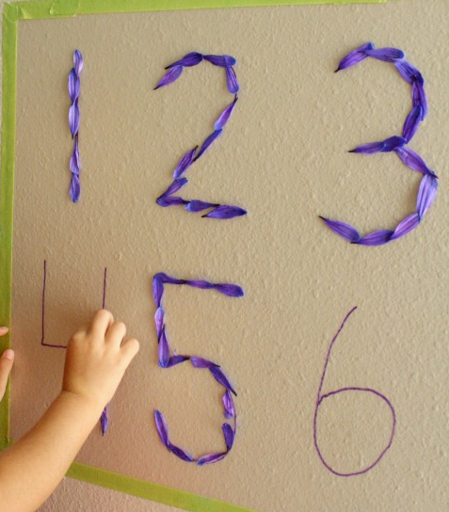
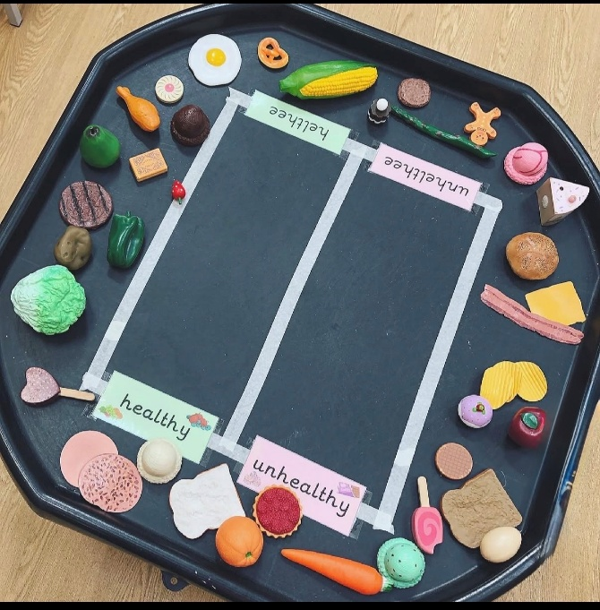
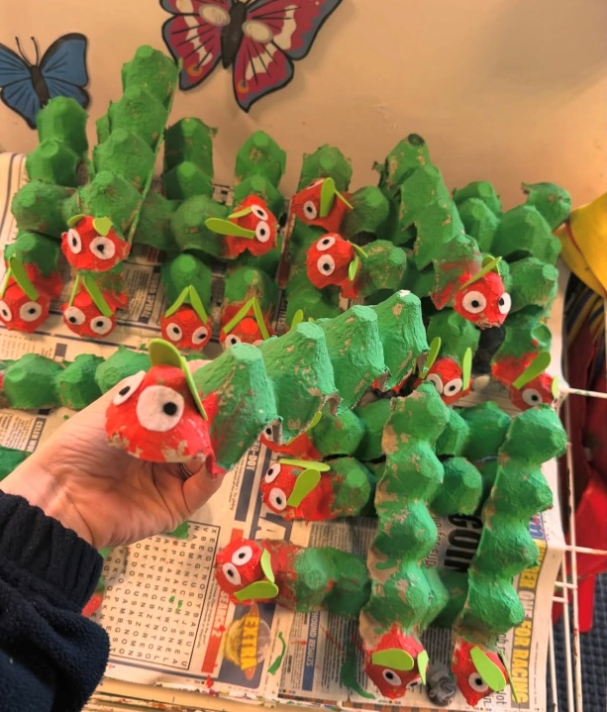

Example of PF/SF planning (can be adapted down to Pathway 1 or Pathway 2)
Literacy/Communication– see focus texts examples
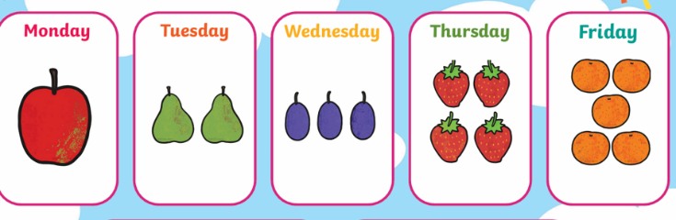
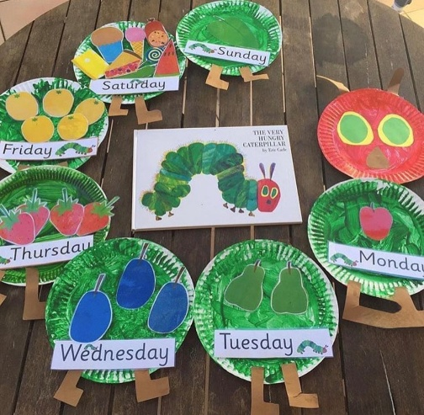
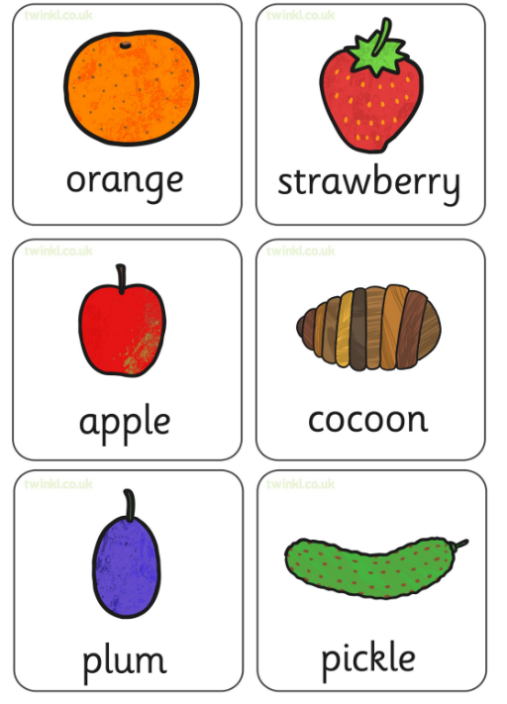
Week 1-
Have visuals in tuff tray with real life objects and sensory materials. Children to engage with and be exposed to the real- life objects. Begin to make links.

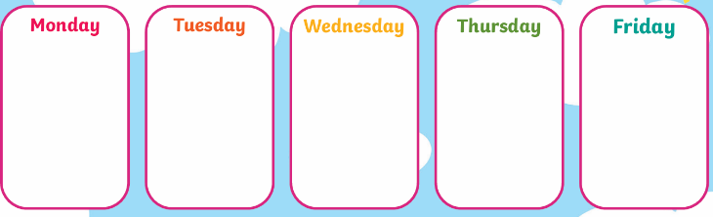

Week 2-
Have the key part of the story available – either with a model to match or a blank one for independence. Start 2/3 parts and build up throughout the week

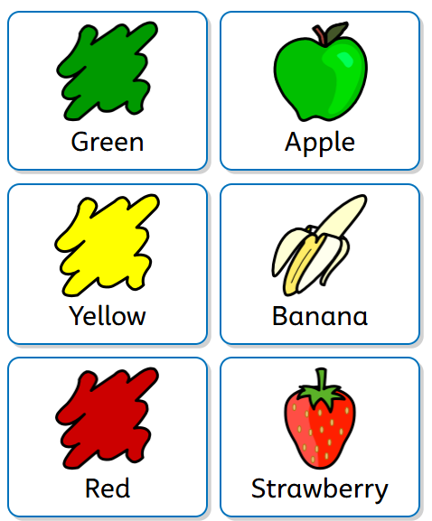
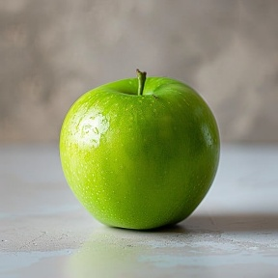
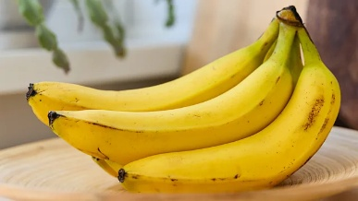
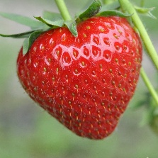
Week 5-
Have visuals to describe a range of fruits. Cut these out for children to choose the correct visuals to match together to describe the fruit. Pictures of fruit however real-life objects is preferable

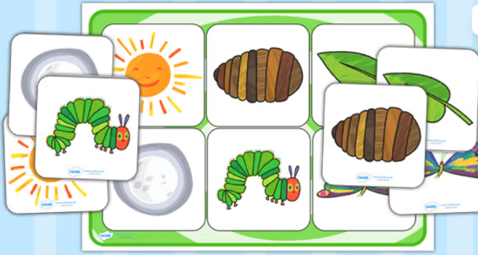

Week 3
Children to match visuals to objects of reference. At the table, have a visual of a fruit and children to choose the correct fruit from a selection of fruits
Week 4
Children to match visuals to visuals.

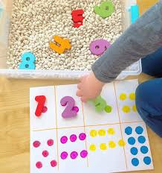
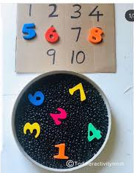
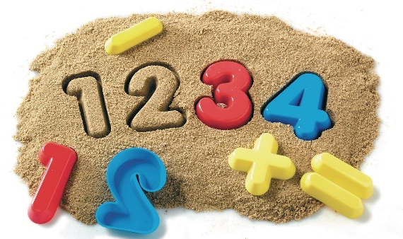
Maths
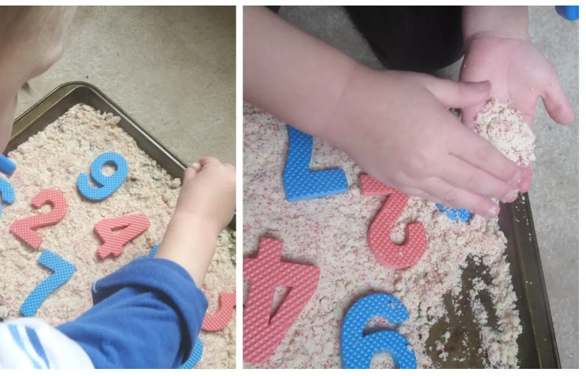

Week 3 & 4
Using manipulatives and visuals to represent up to 5
Week 1 & 2
Sensory exploration with number – children to engage with and be exposed to different numbers through sensory play

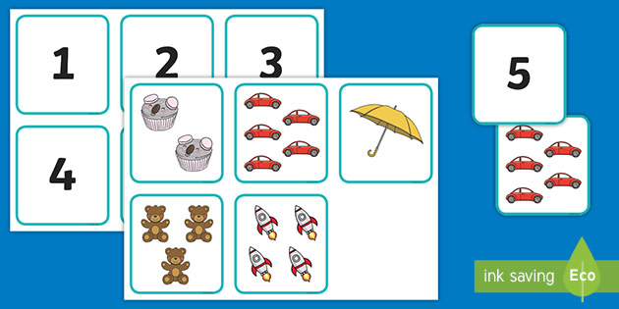
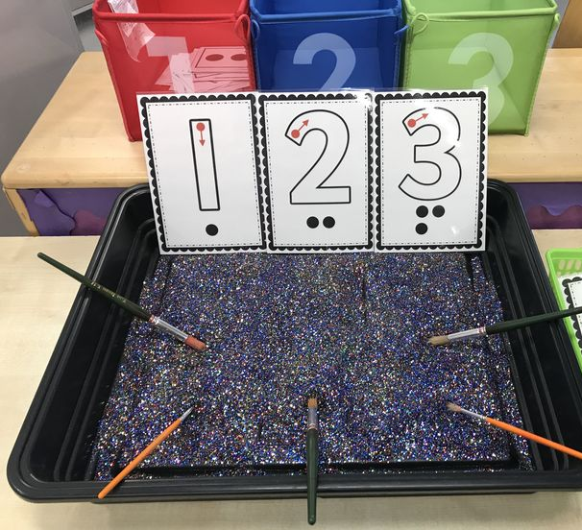

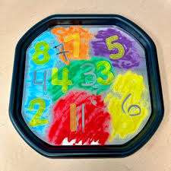

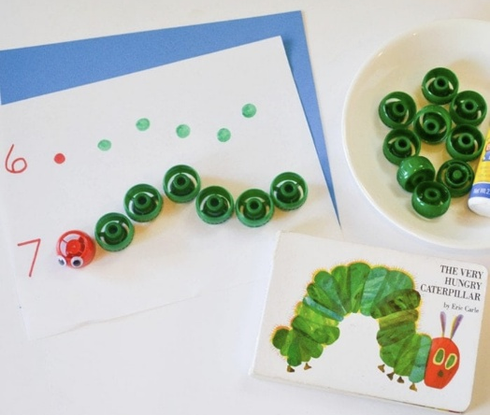
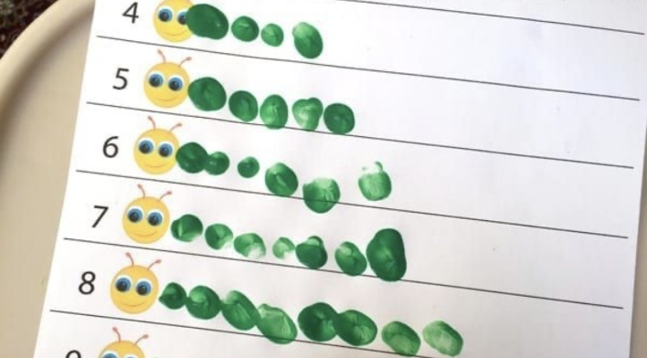
Week 5
Ordering numbers -linked with focus story

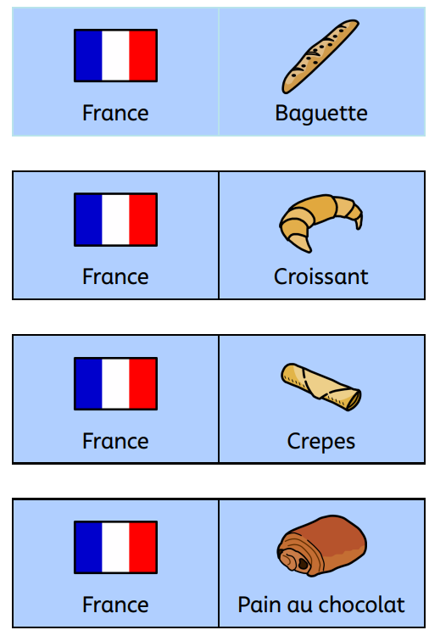
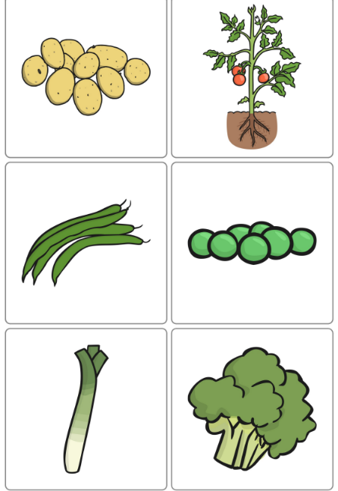
Science/UTW Resources
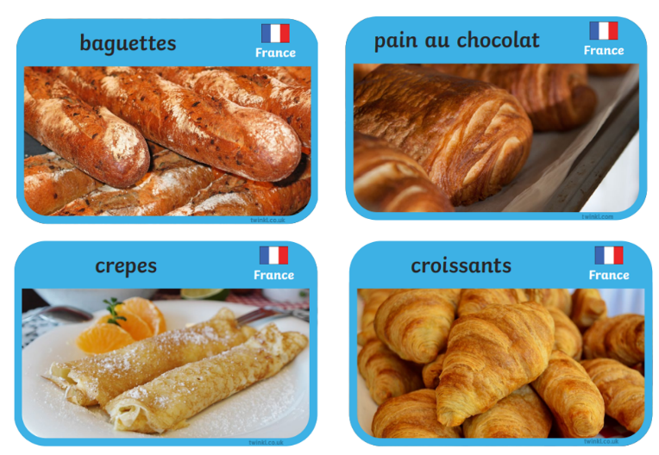
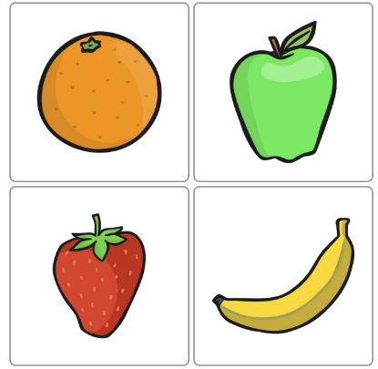

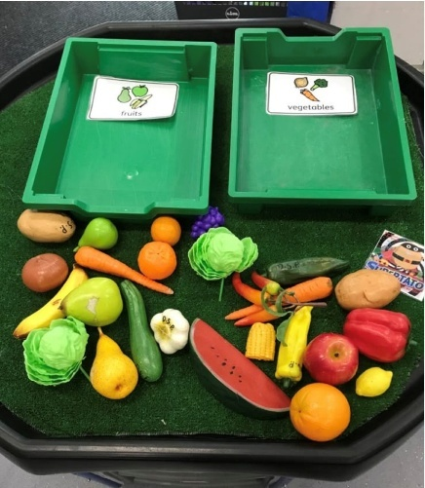

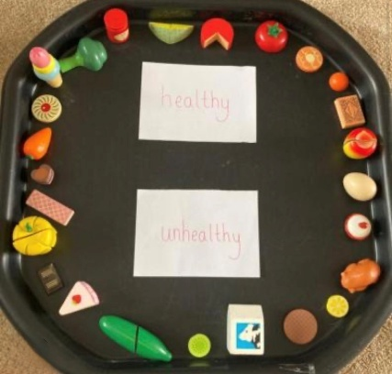
UTW
Each week to focus on a different country. Cut the widget cards out so the children have to match together. Use the real-life pictures to match as well
Flag card – Widget card – Real life card.
These are colour coded to help support matching
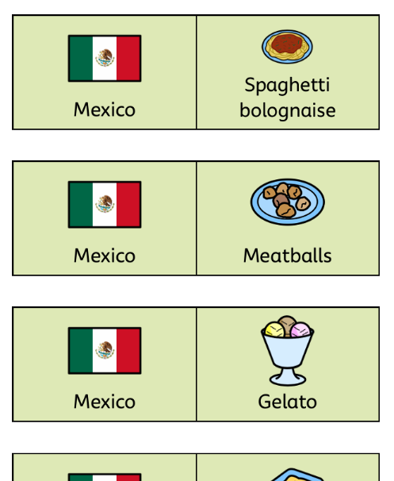

Science
Week 1-4
Identifying and matching fruits and veg using visuals and real-life fruit. Adults to model language. Children to have the opportunity to choose as this is communication focus
Week 5
Practical sorting activity – see above

PSHE
Week 1
Key Vocab- Healthy, Fruit, Vegetables, Water.
Materials – Toy or real fruit and veg, paper plates, visual choice cards, pictures of fruits and veg.
During session
Sensory exploration – children can touch, smell, look at the foods. Encourage naming colours, matching foods, describing textures.
Task - Make a healthy plate -Children to glue pictures of healthy foods onto the plates.
Review- review with visuals “water is healthy” “Fruit helps our body”
Adaption - Visuals for children who are non-speaking, offer physical objects, reduce number of choices
Week 2
Key Vocab- Exercise, Move, Jump, Stretch
Materials – Music, movement cards, beanbags, cones, stepping stones.
During session
Sensory exploration – warm up - play music and copy simple actions, Jump, Clap, March etc.
Task – How does my body feel – adult to narrate fast heartbeat, breathing more etc. Stretch and relax with calming music
Review- review with visuals “moving is good for our bodies”
Adaption – Allow sensory breaks, first and then boards, Visuals for children who are non-speaking

Week 4
Key Vocab- Sleep, Rest, Calm, Feelings
Materials – Emotion cards, Blankets, Bedtime routine visuals, Calm music, Breathing visuals.
During session
Sensory exploration – Feelings check in – children to choose an emotion card
Task – Story time, read simple story about bedtime routines. Discuss sleeping at night, quiet time, feelings rested. Sequence cards, bath, Pjs, Brush teeth, story, sleep.
Review- review with visuals – Dim the lights and practice deep breathing”
Adaption - Visuals for children who are non-speaking, support, reduce number of choices

Week 3
Key Vocab- Wash, Soap, Clean, Teeth
Materials – Handwashing visuals, toothbrush model, Glitter (germs), soap and water, sequencing cards.
During session
Sensory exploration – children to put glitter on their hands to represent germs.
Task – Handwashing practice (linked with life skills) using visuals. Practice teeth brushing using model or puppet. Sequencing hygiene cards.
Review- review with visuals – singing handwashing or brushing song
Adaption – Sensory friendly soap, allow children to watch before participating, offer step by steps visuals to take home.
k 3

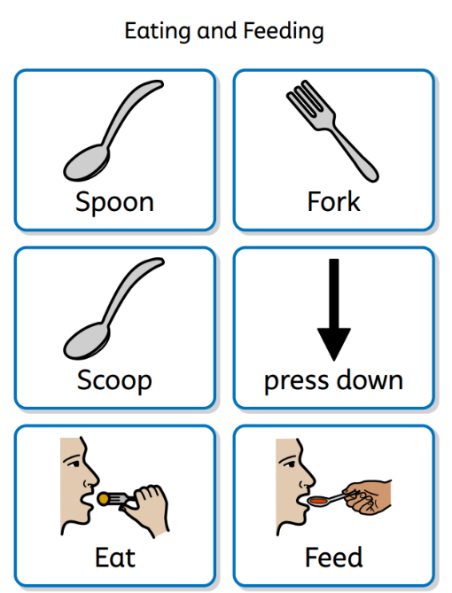
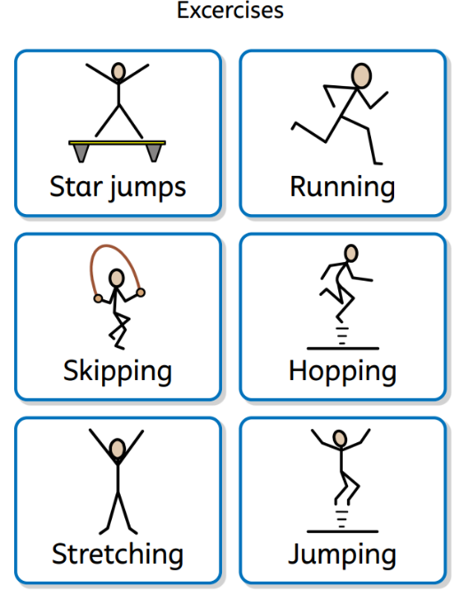
Supporting Visuals
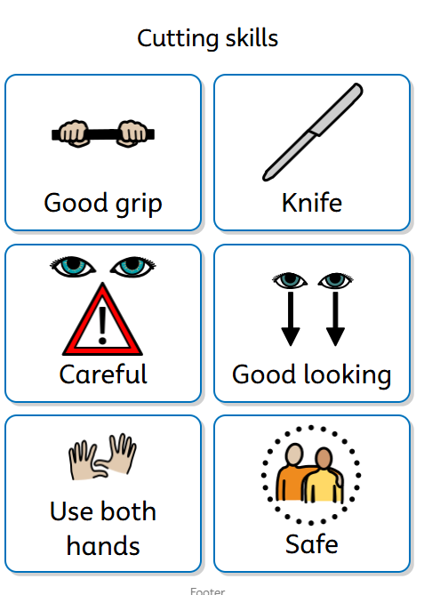

Visuals to support the activities.
These can also be used as part of the display as part of the class environment
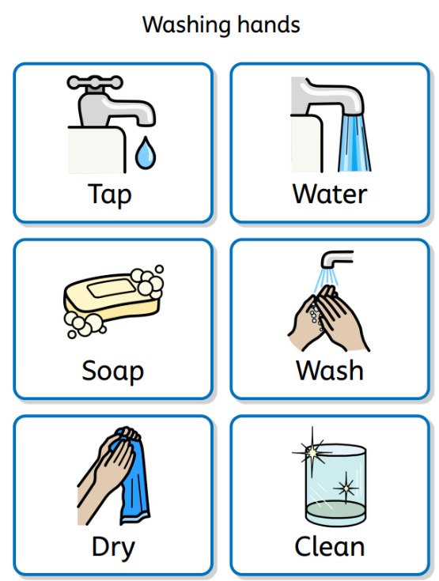
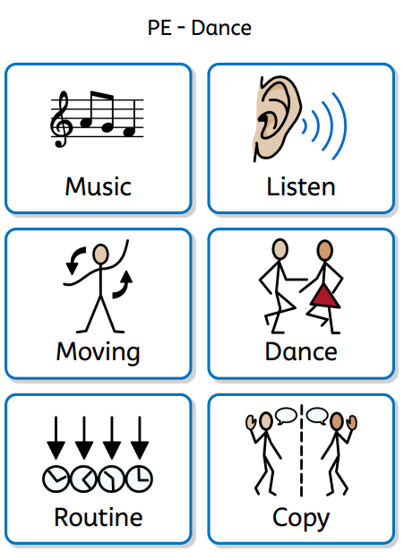

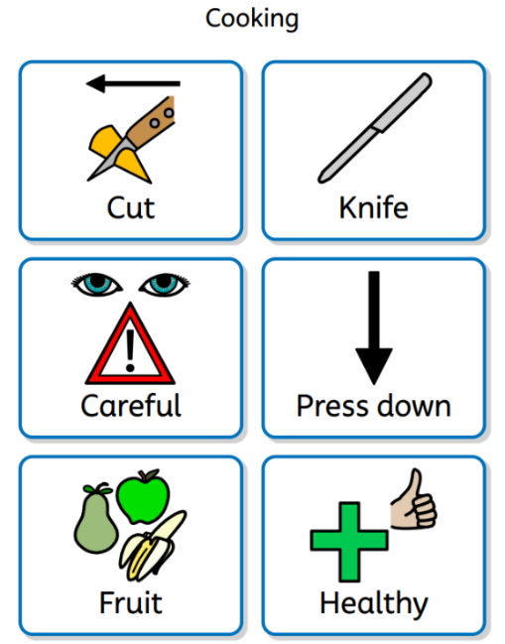

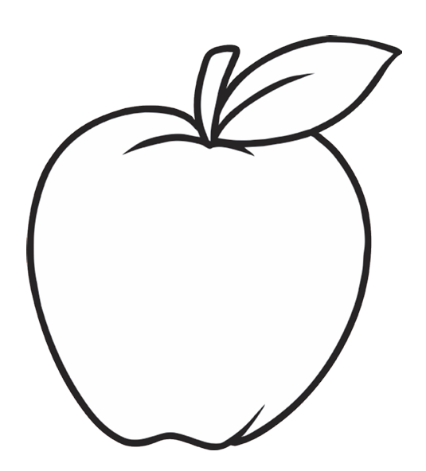
Art Resources

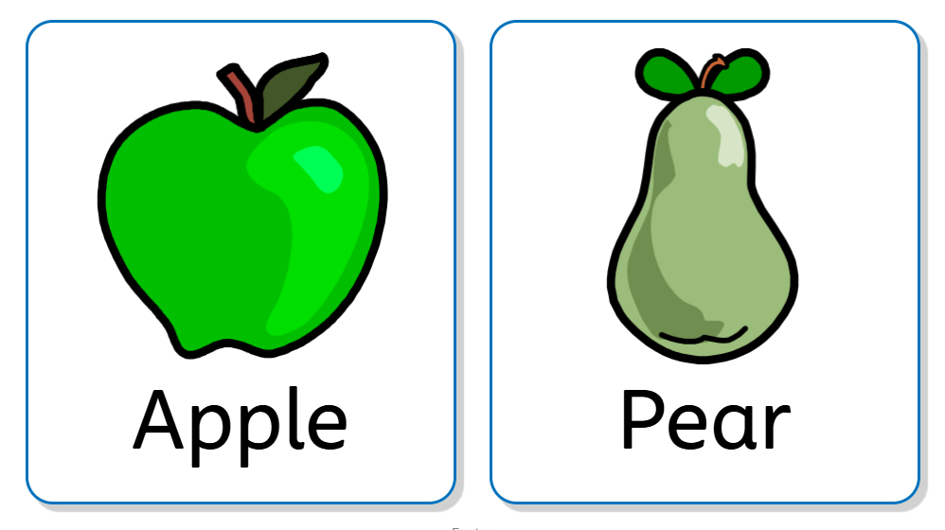

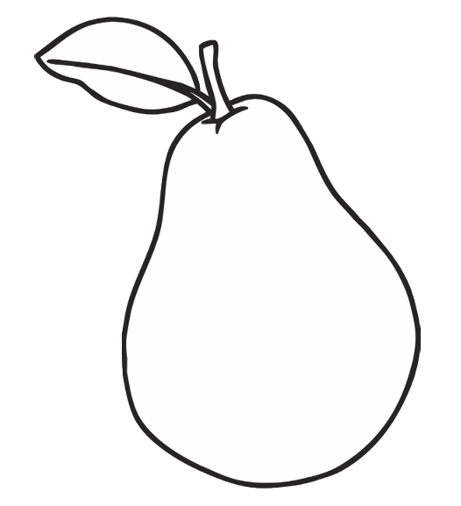

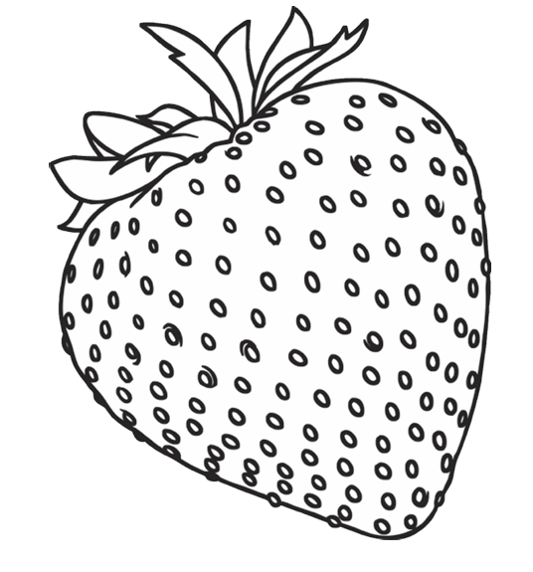

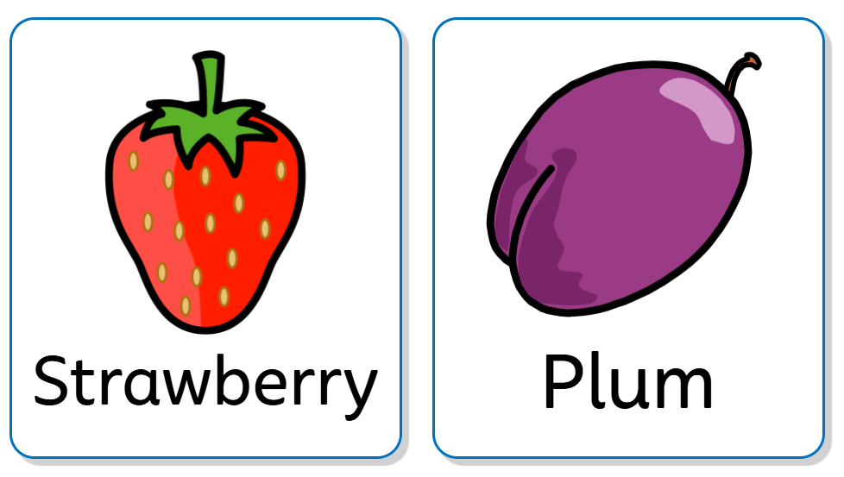

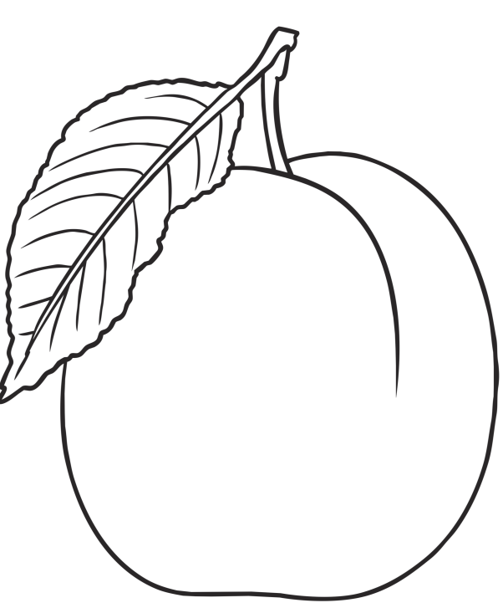

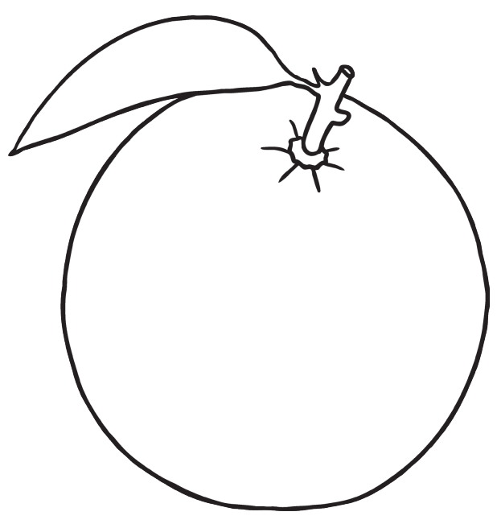

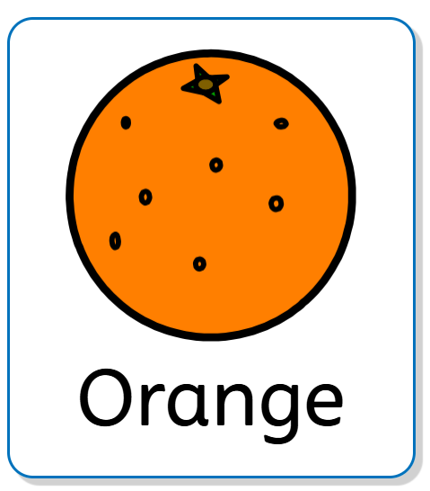

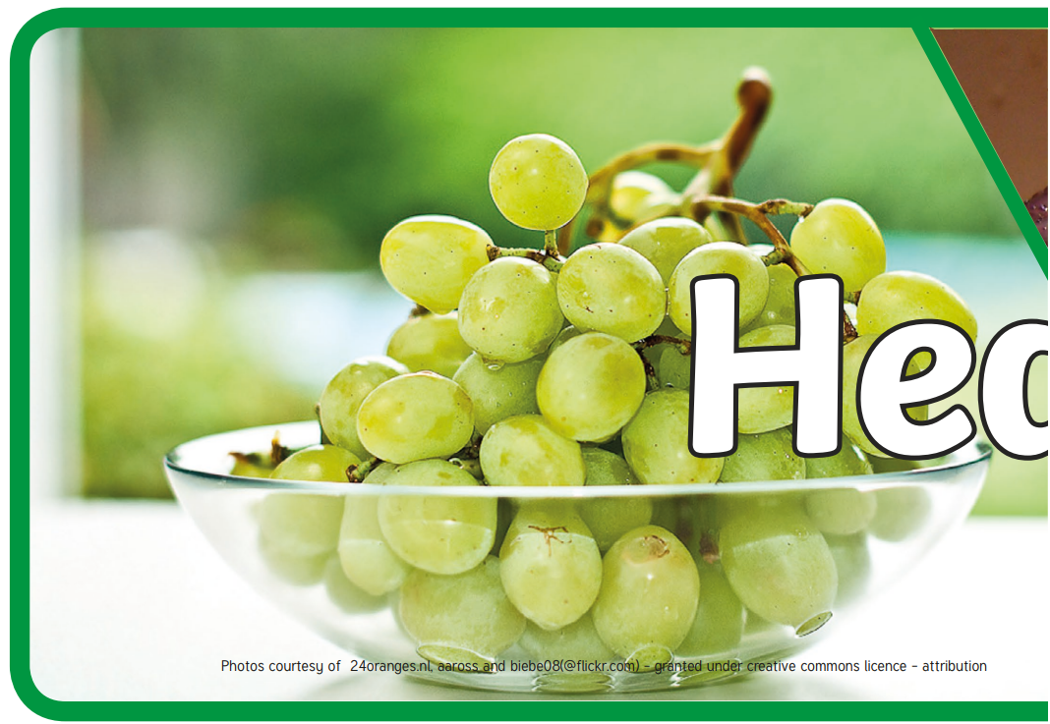
Additional Resources/Display
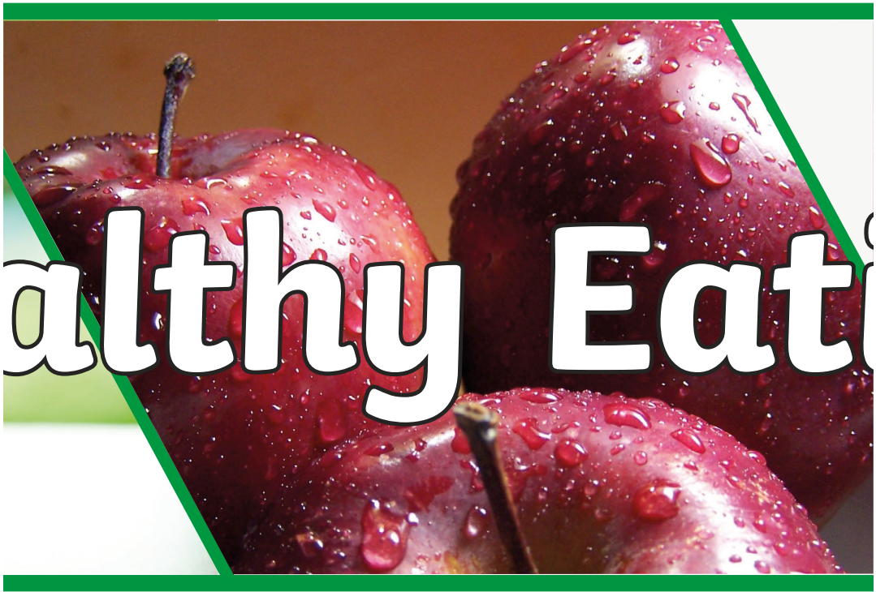
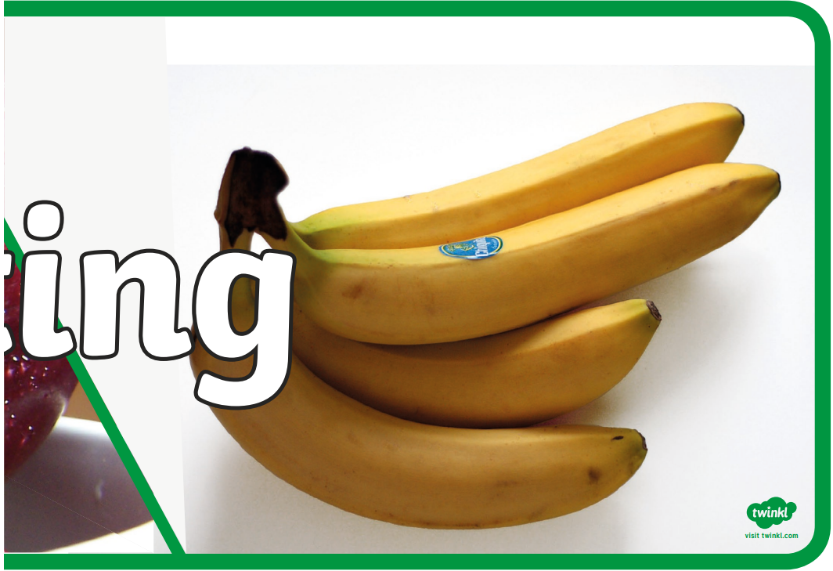
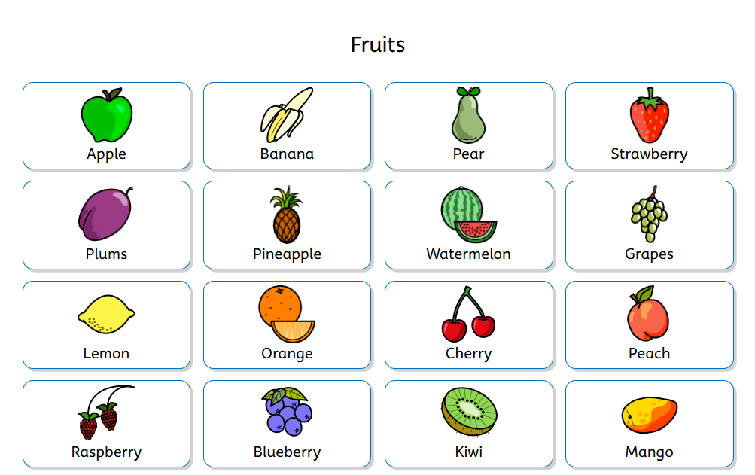

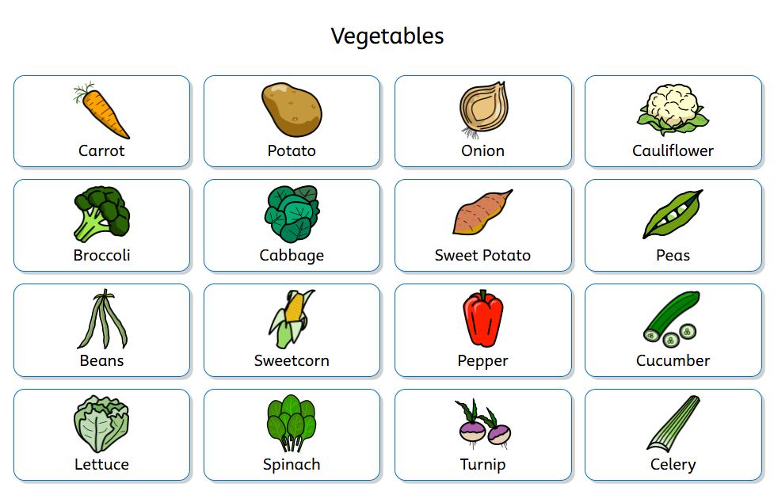

Display
Literacy board
- Title of the focus text (whichever text is chosen)
- Key words from the story – using widgit
- Pictures of children engaging in sensory tasks/working wall
- Reference to the skill which this half term is: Matching

Maths board
- Number/counting title
- Key maths vocabulary using widgit
- Visual number line
- Pictures of children engaging in sensory tasks/working wall
- Anything manipulatives to make a tactile board

Topic board
- Healthy eating title
- Key topic vocabulary - widgit symbols of fruits and vegetables
- Pictures of children engaging in sensory tasks/working wall
- Visual reminders of what has been taught
Art board
- Each week, as the children complete the artwork, this can go straight up on the board with supporting visuals

Assessment links

Links to AAE Pre Formal framework – objectives that are covered during this topic.
Writing - STRAND 1A
- Enjoys sensory play
- Can make marks using different materials (glitter, sand, rice)
- Begin to mark make
- Make marks or symbols in their preferred mode of communication.
- Makes marks in different places (chalkboards, whiteboards, paper etc)

Maths - STRAND 1A
Number
- Pupils encounter activities and experiences. They may be passive or resistant
- Develops an awareness of number names through their enjoyment of action rhymes and songs that relate to their experience of numbers.
- Has some understanding that things exist, even when out of sight.

Maths - STRAND 1B
Number
- Can engage for a short period of time at a number activity
- Can handle manipulatives during the number activity
- Notices changes in number of objects/images or sounds in a group of up to 3.
- Actively explore objects and events for more extended periods [for example, manipulating objects in piles, groups or stacks]
- Apply potential solutions systematically to problems [for example, using items of equipment purposefully and appropriately].
- Knows that things exist, even when out of sight.
- Beginning to organise and categorise objects, e.g. putting all the teddy bears together or teddies and cars in separate piles.

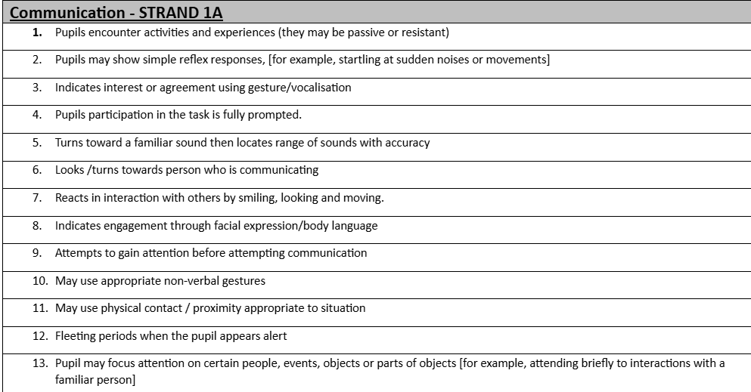

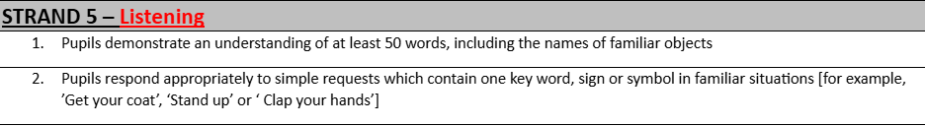

Links to AET framework – objectives that are covered during this topic.
Area of learning | Outcomes
Flexibility, Information Processing  and Understanding (FP)  Problem solving and thinking skills | 4.1 Makes a choice  4.2 Uses information available to make an appropriate choice
Healthy Living (HL)  Keeping healthy | 1.1 Identifies own health needs  1.2 Copes with medical appointments  1.3 Understands benefits and risks of medicines  1.4 Knows how to limit spread of infection (coughs and colds)  1.5 Makes healthy choices in relation to food/ drink  1.6 Tolerates an increasing range of foods  1.7 Makes healthy choices in relation to exercise
Healthy Living (HL)  Personal care | 2.1 Use toilet independently in familiar  setting  2.2 Uses public toilet  2.3 Maintains good hand hygiene  2.4 Maintains good bodily hygiene
Independence and community participation (ICP)  Independent living | 1.2 Prepares a simple snack  1.3 Makes a drink for self and/or others
Emotional understanding and  self-awareness (ESA)  5. Developing confidence and self-esteem | 5.1 Expresses preferences  5.2 Expresses opinions / ideas  5.3 Shows confidence within activities

Links to PfA
Topic: Eating and Feeding

Feeding and Drinking | Can eat independently | Can put food in their mouth without support | Can use a spoon | Can use a fork | Can use a knife to cut food
Feeding and Drinking | Can drink independently | Can drink through a closed cup | Can drink through a straw/closed cup | Can drink from an open cup
Feeding and Drinking | Can eat a varied and balanced diet | Can tolerate new foods on their plate | Can explore new foods (e.g. smelling, touching) | Can put new foods to their mouth | Can try new foods
Feeding and Drinking | Can recognise when they are feeling hungry and thirsty | Can act on when they are feeling hungry | Can request food when hungry | Can act on when they are feeling thirsty | Can request a drink when thirsty
Feeding and Drinking | Can respond to hunger and thirst | Can get themselves a snack or drink | Can make themselves a simple snack e.g. toast or a sandwich | Can plan to make a meal | Can cook a meal

