Inclusion and SPECIAL EDUCATIONAL NEEDS & DISIBILITY strategy
An overview of our provision for children with SEND at Children First Academy


CONTENTS

Section 1 – Overview
Section 2 – SEND Pathways
Section 2 – Leadership
Section 3 – Role of the SENCo
Section 4 – Offers of support
Section 5 – Additional Provisions (Inclusion Bases)
Section 6 – Curriculum & Assessment Overview
Section 7 – Monitoring and Quality Assurance
Section 8 - Appendices

Associated documents:
- Quality of Education Strategy
- Head teacher’s Report
- School Improvement Plans
- Assessment Strategy
- School Evaluation Form
- SEND Policy
- EYFS Policy

Section 1 – Overview
At Children First Academy Trust, we have a deep understanding of SEND and inclusion. We recognise that being inclusive means ensuring all have equal opportunities to achieve but also embracing differences and individuality that play a part in progress made. We value collaboration and working together, to ensure Inclusion is kept at the forefront of our thinking and decision making, understanding that all can play a role in creating an inclusive environment. Our values of Aspiration, Integrity and Resilience are pivotal in ensuring children with SEND have equal access to making progress.
- The Vision
‘Inclusion for all’
Our vision for is for all pupils to have access to a broad and balanced curriculum, appropriate for their stage in life, to achieve through this curriculum and have a positive experience of school. All pupils, irrespective of need, have the right to rich curriculum that will develop knowledge and skills. Children with SEND are no exception to this. It is our duty to ensure children with SEND have equal opportunities to experience a wide and varied curriculum that allows each individual to develop academically, socially and personally.
Our core value is-
We will always assume competence for each child engaging in a learning experience, ensuring there is no limit or restriction to their potential to learn.
- Turning the vision to reality
It is important we know how to turn the vision into reality, we will do this by
- Providing the AAE curriculum to allow schools with an Inclusion Base, ensuring a robust and comprehensive curriculum offer for our most vulnerable children
- Ensure our mainstream curriculum delivery is inclusive, through the use of the high-quality inclusive strategies
- Prioritise high quality CPD for all staff, including leaders, in the area of inclusion and SEND
- Invest in equipment, resources, environments and expertise to enhance our offer
- Be open minded, sharing expertise in the trust and outside professionals
- Seek feedback from all involved – children, parents, staff, leaders, local authority.

- The Vision in Practise
To put our vision into practise, our leaders and teacher will
- Daily demonstrate our core value of always assume competence in every learning opportunity – ensuring high expectations for the children
- Ensure lessons are planned with the children at the forefront – delivering learning opportunities in different ways
- Use inclusive strategies so no child is left behind
- Carry the philosophy that what’s good for one is good for all
- Be risk takers in finding different ways to engage children who face challenges, discovering the best solution for them
- The Four Pillars
Our SEND and Inclusion vision are underpinned by four pillars to ensure our children with SEND have the very best offer

Success Markers
Success may look different but holds the same value. We acknowledge that each child with SEND is on their own individual learning journey and develop at their own pace. We recognise that progress can take many different forms. Our markers of success are where we begin to see progress in all areas of the child’s development – in academic, personal, social and emotional. We must ensure our children are given the tools needed to navigate life in the wider world. As the children grow through the trust, we would see a development in our children from their starting points. Where progress is stalled, we can drill down deeper and change our approach as to why
Shared responsibility
We are all teachers and leaders of children with SEND. Supporting children with SEND is a responsibility of all adults within the trust, no matter the role. From our trust executive team making key decisions, to our headteachers ensuring good outcomes and environments, to our SENCo’s who ensure our schools are providing tailored and appropriate support, to teachers and support assistants who provide engaging and immersive learning experiences, we all have a key role to play in ensuring our children with SEND get the very best deal. Creating and establishing an inclusive ethos is fundamental ensuring this takes place. Responding to the call to act on behalf of our children with SEND is important to ensure decisions are made with children at the centre.
Success not Shortfall
Equal opportunities for all, inclusion at its finest. We believe every child, including those with SEND should have the opportunity to succeed, irrespective of challenges they may face. It is our responsibility to ensure children with SEND are exposed to and can access the exact same opportunities as those of their peers. We continue to strive for inclusive classrooms and environments, removing any shortfalls or potential barriers to learning and progress with high expectations for all. Within our trust, children are all seen as individual and are celebrated as this.
Individual but not Isolated
Acceptance for all, creating inclusive school communities. It is important to keep at the forefront that each child is an individual. Whilst we provide different environments as part of our SEND pathways (see below), we will keep the fact that children are individual as central pillar. Ensuring children access, where appropriate, bespoke learning opportunities, environments, professionals, strategies and resources. We will do this through our inclusive practise model within our mainstream classroom and Inclusion bases at each stage, to ensure children’s individual needs are met and are not isolated because of them.

Section 2
The Trajectory Pathway
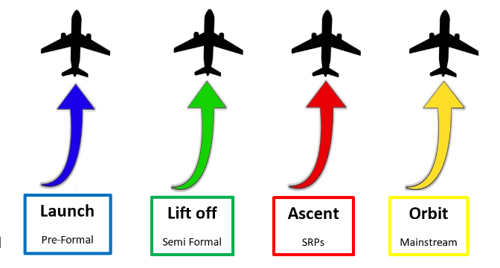

Why Trajectory?
Definition: A trajectory is sequential path describing how learners develop knowledge and skills over time, transitioning from informal ideas to complex understanding.
We want our learners with SEND to have the opportunity to travel from the informal to more complex learning experiences and to have a clear, robust, supported route to achieve this.
Who is Trajectory Pathway for?
The Trajectory pathway are for pupils with SEND in different provisions and environments across our schools, from the pupils accessing our pre-formal environments right through to children accessing our mainstream provision. Each stage ensures individual needs are met at an appropriate level. The stages allow us to provide for each individual’s specific needs, even down to the type of resources and experiences they require, breaking down any potential barriers to learning. Our stages aren’t labels; they are a guide to ensure the personalised learning experience that our pupils can expect. Using the stages as a starting point, we tailor the learning to each child’s aspirations, needs, age and stage. Through regular and thorough assessment of all areas of learning, children can move between each stage when this is appropriate and are therefore never limited.
Each child is on their own trajectory.
We want to ensure that for our pupils with SEND, nothing is impossible and there is no limit to what they can achieve
Pathway | Type of provision | Profile
Pathway 1  Launch | Pre-Formal | Our Pre-Formal learners are at the beginning of their learning journey. They will:  - Be developing their communication & interaction and will engage with the curriculum at a sensory exploration level.  - Non-verbal/pre-verbal, beginning to use gestures, signs or symbols, to communicate.  - Have severe communication difficulties to varying extents, impacting both expressive and receptive skills  - Have difficulties in social interaction, communication skills, sensory integration and emotional regulation  - Need consistent structure and routine are essential in these environments  - Need a curriculum that will be topic based allowing for constant exposure to new vocabulary and repeated one-to-one tasks tailored to individual needs  - Have an emphasis on learning life skills, self-care and physical development.  - Need continuous provision providing constant learning opportunities.
Pathway 2  Lift off | Semi-Formal | Pathway 2 is a continuation of Pathway 1, developing the structure and routine within the classroom setting.  - The environment will have more designated areas of learning that the children will engage in for a sustained period of time.  - Children will continue to develop their communication skills by their preferred method of communication.  - Adults will still need to structure and support communication with communication tools such as Widgit symbols, objects of reference and Makaton when necessary.  - The curriculum will be a continuation from Pathway 1, however will be adapted to allow for knowledge and skills to be developed  - Clear learning journeys throughout the term to meet objectives.  - Children will be prepared for a more formal curriculum by developing their phonics writing and numeracy skills will a continued focus on self-care, life skills and physical development
Pathway 3  Ascent | SRP | Pathway 3 is a Specially Resourced Provision (SRP, known previously as ARP).  - Supports the children who can access mainstream at set and designated times, through carefully planned integration.  - Acts as a stepping stone to bridge the gap for children with SEND to have mainstream experiences.  - Children are taught from the national curriculum that is adapted for their level, ensuring they have foundational knowledge required.  - The formal classroom environment allows children to have tasks that are at their own individual level, requiring careful planning and adaptation.  - There remains a focus on life skills and preparation for adulthood, however at a more advanced level than the previous Pathways.  - Children may have developed their communication skills to be able to express themselves and engage in discussions, however consideration needs to still be given to support the children on how to communicate appropriately in different situations.
Pathway 4  Orbit | Mainstream | Pathway 4 is for our children with SEND who are accessing the mainstream setting.  - They do not require an alternative or additional provision and have developed their communication skills significantly to be able to make progress.  - Inclusive practise and careful planning should be in place to ensure the needs of the individual are being met.  - The universal, targeted and where necessary specialist offer should be in place, with consideration given to any reasonable adjustments, to ensure the children with SEND are given the same opportunities to make progress in all areas as their peers.  - All children should be tracked on an IEP to monitor steps of progress, not only academic but also personal and others areas where the child may still need support.  - Teachers should have sufficient knowledge or should be able to access support to ensure they are equipped with resources and specific learning strategies to allow the child to achieve.  - Children may need an adapted curriculum within their year group and this should be carefully monitored to ensure the gap is closing.

Section 3 – Leadership
- Role of the Headteacher
All Headteachers in our trust are committed to ensuring inclusive practise. This is reflected on each individual school’s SEF, ensuring SEND and Inclusion is kept as an ongoing priority. The Headteacher has strategic leadership in prioritising and overseeing SEND in their schools. Below are elements of Leadership that a Headteacher must be focused on:
- National, Regional, Local context of SEND inc: OFSTED
- Leadership of SEND and Inclusion
- Role of SENDCo/Inclusion Lead
- SEND focused CPD
- SEND policy and procedure
- School website
- SEND and Governance/Trustees
- Other external validation
- Achievement
- Outcomes for pupils
- Monitoring and Evaluating SEND
- SEND and other vulnerabilities
- Funding
- Inclusion Bases and additional provisions

- Role of Senior Leaders
Senior leaders have a responsibility to ensure Inclusion is kept paramount in our schools. Along with Headteacher, Senior Leaders need to have a clear understanding of what inclusion is and how to ensure an inclusive environment and inclusive practise is maintained. Areas that need to be considered are:
- Adapted and Adjusted curriculum
- SEND specific Monitoring
- Evaluating the effectiveness of the curriculum
- Curriculum leads have an understanding of SEND in their subject areas
- SEND specific learning walks with SENCOs (including Inclusion Bases)
- Phase leads/AHTs to have awareness of progress made by SEND learners
- Analysing of SEND data
- Effectiveness of interventions
- Ensuring daily inclusive practise at different levels – Universal/Targeted/Specialist
- Ensuring EYFS Specific Inclusive practise
- Quality assuring Inclusion Bases (ARPs and Units) with SENCO
- Providing coaching and support for colleagues

We have developed a Leadership of SEND Self Evaluation Form to identify in each school the areas for development:
Element | Content | Narrative | SEF – Areas to develop
Leadership | National, Regional, Local context of SEND | - OFSTED 2025 and Inclusion focus  - Role of case sampling and learning walks  - White Paper  - Curriculum and Assessment Review  - National – general information  - Increased emphasis on inclusive, mainstream settings.  - Increased focus on wellbeing  - Enfield focus areas for consideration
Leadership | Leadership of SEND and Inclusion | - School culture  - SDP – aligned with whole school priorities  - Vision of SEND and Inclusion clear and focused  - Dissemination of priorities to leaders  - Evaluating and monitoring of SEND/Inclusion – all leaders  - Learning walks – regular and focused  - SEND and Inclusion role for:  HT, DHT, SLT  Middle/Phase/Curriculum Leaders  Class teachers  All Support staff awareness of needs including office staff/site staff  - Specialist staff  Outside professional staff/bodies
Leadership | Role of SENDCo/  Inclusion Lead | - SENDCo and school leadership role  - SEND Vision and values disseminated to all
Leadership | SEND Focused CPD | - All staff included in the offer  - Any specific training for Inclusion Bases
Leadership | SEND policy and procedure | - Documentation - regularly updated  - SEND Offer  - SEND Policy  - Documentation - reflecting current offer  - Identification processes and identification pathways  - Graduated approach  - Information sharing  - Links with other policies – eg Behaviour and Relationships and linked with below
Leadership | School website | - Compliance  - Promotion and celebration of SEND  - What does it say about how the school feels about Inclusion?  - SEND Offer  - SEND Policy
Leadership | SEND and Governance/  Trustees | - SEND governor involvement
Leadership | OFSTED and other external validation | - HEP IP visits  - Reviews  - LA QA visits for ARP ‘s and units, Nurture
Leadership | Achievement | - Pupil Progress Meetings – leaders inc SENDCo to attend  - Systems used to measure smaller and different steps of progress  - Progress from all learners.  - Assessment system meeting needs inc all additional provisions in school  - Possible SEND specific assessment systems (Birmingham Tool kit, BSquared,PIVATs) or integrated into your whole school system
Leadership | Outcomes for pupils | - IDSR headlines  - External data headlines  - Internal data headlines
Leadership | Monitoring and Evaluating SEND | - SEND specific learning walks  - SEND Book looks  - SEND pupil voice  - Parent voice
Leadership | SEND and other vulnerabilities | - Intersectionality examined  - Racial Equity
Curriculum / Curriculum Leads | Adapted and Adjusted curriculum | - HQ teaching and learning for all  - Adapted and adjusted curriculum areas  - Documentation that details adapted and adjusted curriculum  - Support for teachers and other educators
Curriculum / Curriculum Leads | Monitoring and Evaluating the curriculum | - Documentation used to monitor and evaluate  - Curriculum subjects adaptation list  - Learning walks with other leaders inc SENDCo  - At least half-termly re adaption and adjustment in classes
Curriculum / Curriculum Leads | Curriculum leads and SEND | - SDP priorities for curriculum and SEND  - Are leaders working across the school to support all learners eg in the Inclusion bases (ARP,Units etc)
Curriculum / Curriculum Leads | Daily provision – Universal/Targeted/Specialist | - Is inclusive practise embedded?  - Do all children receive the universal offer?
Curriculum / Curriculum Leads | EYFS Specific | - Foundational knowledge – adapt and adjust curriculum plans for this and rise in complex needs
Curriculum / Curriculum Leads | Curriculum Pathways offered | - Main school  - Inclusion bases (units, ARP/ARB)

- Role of the SENCo
The SENCo should be on the Senior Leadership Team according to Ofsted guidance. This ensures SEND and Inclusion is kept central in school wide decisions. SENCos are integral to the strategic direction of SEND within our schools and ensuring the best quality provision for our children with SEND. Apart from the SENCo statutory duties, there are different aspects that are important to ensure children with SEND have the opportunity to be successful.
Culture
As a leader of SEND, the SENCo promotes the school culture of inclusion. The vision should be clear and focused. The SENCo, along with Senior Leaders and Headteacher, should foster a culture within the school of inclusion and acceptance, ensuring all pupils’ needs are met, irrespective of any challenges they may face. SEND and Inclusion should be forward facing, an area that the school should pride themselves on where all staff, especially leaders can share what the school does well to support the most vulnerable children.
Shared Expertise
The SENCo’s in our trust are experienced and knowledgeable. They hold a vast amount of expertise. SENCo’s must feel empowered by their Headteacher to share their knowledge and have real impact and change. The most valuable use of SENCo’s time is supporting colleagues, providing training and identifying strategies that support children in their setting. SENCos should shape the ground SEND and Inclusion is built on their schools, being catalysts for high quality inclusive practise, meeting the individual needs of children.
Ensuring SEND and Inclusion is a priority
Linking in with the culture of the school, SEND and Inclusion should be clearly evident on the SDP. The SENCo must work with leaders to ensure SEND and Inclusion is woven through the objectives on the school development plan. This is to ensure Inclusion is kept central. It also ensures all leaders keep SEND and Inclusion at the forefront, aligning it with the whole school priorities.
Dissemination of knowledge to leaders
SENCos are pivotal in ensuring leaders are aware of the SEND and Inclusion expectations. This includes Phase Leads, Subject Leads and other key roles such as pastoral leads. The SENCo will hold the knowledge of what is needed to best support children with additional needs, they also must disseminate it to leaders so they in turn can ensure Inclusion is strong in their respective areas.
Quality Assurance
The SENCo is responsible for Quality Assuring the provision and offer the children with SEND are receiving. Regular learning walks should take place with a clear focus, each time with a different focus of SEND and Inclusion, allowing the opportunities to dig deeper to monitor and establish what is happening in the classrooms. Learning walks should also take place with other members of SLT and with curriculum leads, sharing expertise between leaders to ensure children with SEND have equal opportunities to access all areas of the curriculum, and to ensure it is adapted where necessary.

Section 4 – Types of support
Our Leaders will use the same shared language across the trust to identify the types of support and individuals/group of children need.
- Universal offer
The Universal offer is available to all. It allows support to be put in place with the focus of prevention and to support the children who may benefit, particularly children with SEND. This foundational offer is available to all children, starting with high quality teaching. The universal offer includes inclusive strategies, specific resources and an adapted curriculum, ensuring barriers are removed to allow all children to access learning.
High quality teaching is imperative as a solid foundation for all children, especially those with SEND. It is widely known that what is good for one child, is good for all. This highlights whilst inclusive practise benefits all children, it is imperative for children with SEND.

Inclusive
High-Quality Teaching

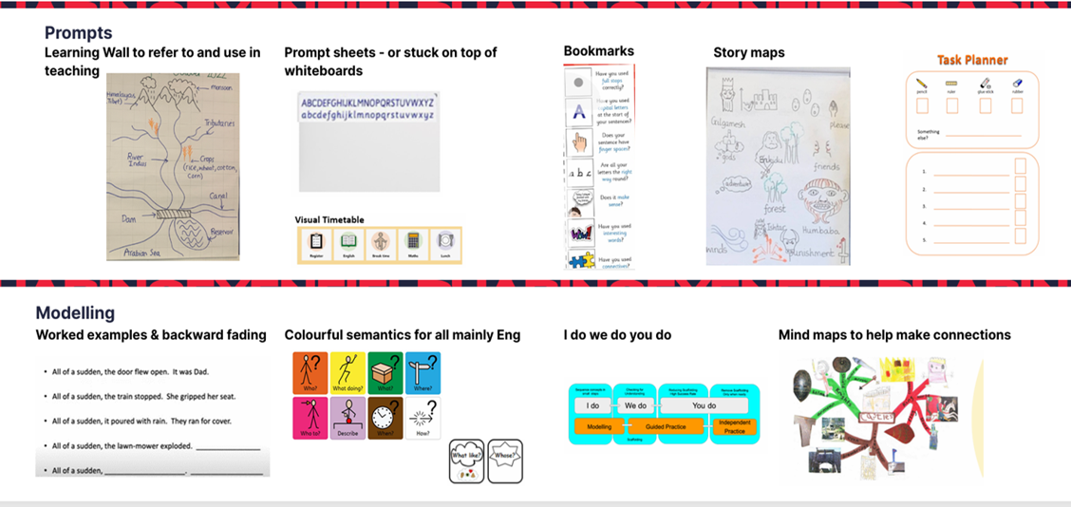
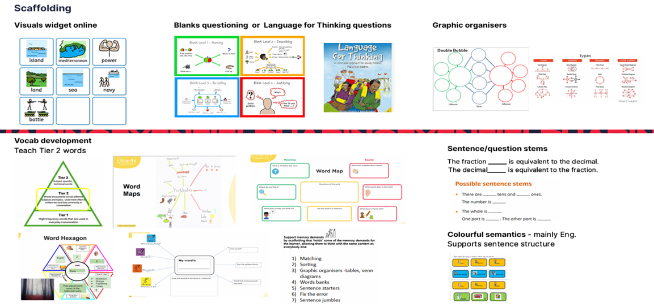
Inclusive Strategies
These are the Trust’s recommended High Quality Inclusive Strategies. These are suggested examples for schools to ensure inclusion approaches are implemented and used across the curriculum.
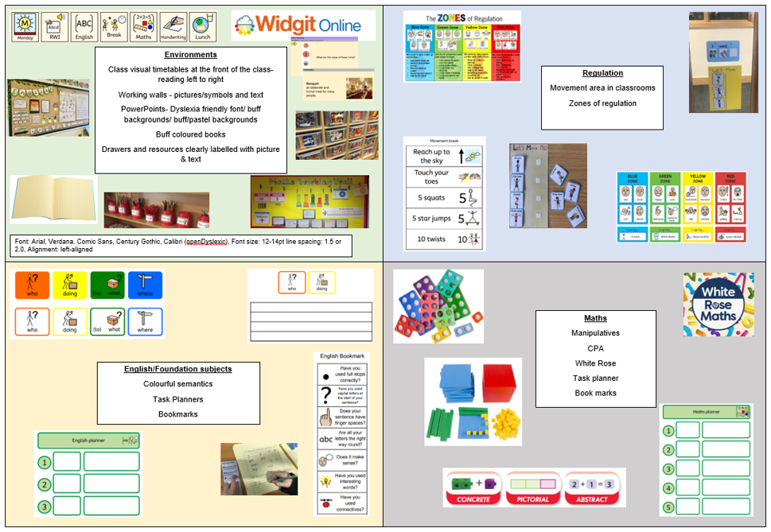
Our Working Party (January – April 2026) developed a set of strategies that are to be used in each of the teaching spaces within each of our schools. This is our minimum expectations for our classrooms to ensure the universal offer is being delivered

- Targeted Offer
High quality universal teaching should reduce the need for extra support for all children. However, some children will need additional support to make progress through selected interventions, resources or support. These specified interventions are additional to and should take place alongside the Universal offer.
Targeted intervention can be a short-term intervention or may become a strategy, opportunity, resource or equipment that becomes part of the child’s every day provision in class. Examples of these could be
● Class visual timetable constructed and used to share what is coming next.
● Small group phonics & spelling support
● Booster groups in maths, reading and writing
● Density of information taught is reduced and information presented is chunked to encourage active engagement.
● Strategies to actively develop learners’ imagination are employed through storytelling e.g. props and puppets and story boxes.
● In class support from additional adults.
● Personalised resources

- Specialist Offer
Some children with more complex and significant needs may require specialist support or services to what the school or setting can ordinarily offer. The children will be identified on the SEND register and will have an EHCP which outline the further support they require.
Specialist support does not always need to be delivered in a specialist setting. Children requiring specialist support will have access to interventions or provision over and above that which is ordinarily available. This could be by attending an onsite Inclusion Base or having a bespoke offer within the classroom. It could also include accessing outside professionals such as Educational Psychologist or outreach services.
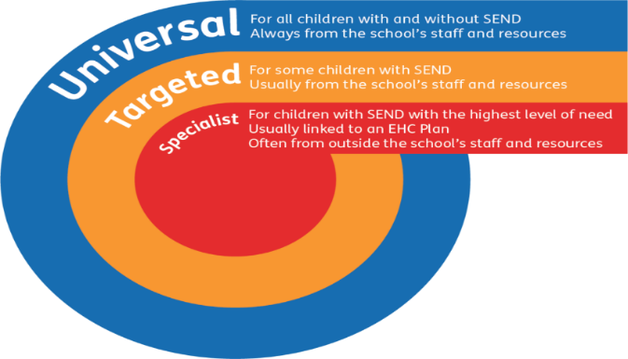

- Creating an Inclusive Culture
Across our schools, we strive to create a culture that is fully inclusive of all children. We will continue to build our environments so all children feel respected, supported and able to participate fully regardless of challenges they may face. Through our universal offer and high-quality teaching, children are receiving the best deal

- High expectations – Having high expectations for all children, irrespective of any challenges they may face.
- Graduated approach – for our children with SEND, we will embed the graduated approach into our ongoing assessment of the children, ensuring we are providing appropriate strategies that are monitored and reviewed.
- Sense of belonging – every child is seen and heard. They need to feel safe and secure to ensure they are in a place where they feel they can participate and learn.
- Inclusive Teaching – using and adapting teaching methods to support different learning styles and abilities. Encourage children to work together who have different strengths and challenges.
- Reasonable adjustments – ensuring there is no learning missed due to a child not being able to access. Where appropriate, reasonable adjustments should always be sought to give the child the same opportunities as their peers.
- Learners not labels – all children are seen as equal. Where a child has an additional need, they are not seen as this. We need to ensure we speak positively about children, always speaking on what they can do, not grouping children based on what they can’t do.
Section 4 – Additional Provisions
(To be read in conjunction with the AAE curriculum document)
The White Paper (February 2026) names additional provisions under the definitions below:
Inclusion Bases: We will replace the current terms SEN unit, resourced provision, and pupil support unit (sometimes referred to by settings as ‘internal alternative provision’) to make it easier for parents to understand the support available for their child. Instead, we will collectively describe this provision as ‘Inclusion Bases’.
- Types of Provision:
Across our schools, we have a high number of additional provisions that support our most vulnerable children. Having these bases in our school aligns with the vision – Inclusion for all. Whilst these provisions vary in type across the schools, these are vital areas in our schools that allow children with SEND to have an offer that meet their individual needs.
The types of provisions we have across the trust are as follows. These titles will eventually change to fall in line with the terminology suggested in the white paper.

- Trajectory Pathways
As mentioned above (page 6) all provisions sit on our trajectory pathways with each stage supporting the needs of children at that point in their journey. The rationale behind the created pathways is to allow for an element of shared understanding as to what each provision should look like. This also allows a degree of consistency across the trust to allow for support and exercises such as moderation. Understandably, there will be slight adaptions to this depending on cohort of children and specific needs they may have, environmental factors and staffing limitations.
- The AAE curriculum
Why AAE?

ACCEPTANCE ACCESSIBILITY ENGAGEMENT
We need to accept the pupil as a whole – their strengths and areas of challenge
We need to create environments and learning experiences that are suitable
We need to engage the children in the environments and learning and opportunities that are appropriate for them

A child-centred curriculum
In our Pre-Formal and Semi-Formal classes across our Inclusion Bases, we have designed and continue to develop a bespoke curriculum to meet the learning styles of our pupils with Autism. Our holistic framework places the child at the centre, providing bespoke learning opportunities which they require and deserve. It ensures that the curriculum’s content and learning experiences are tailored to meet individual needs. Pupils will follow a topic-based curriculum, with both academic and non-academic focus. The curriculum coverage is loosely based on the Early Years Foundation Stage areas of learning and development but are adapted when necessary to ensure a bespoke, tailored approach. These are:
- Literacy/Communication and Language,
- Maths,
- Science,
- Understanding of the world (Humanities),
- Art & Design,
- PSHE,
- PE
Pupils in our provisions will follow a 2-year curriculum cycle with different topics 6 times per year (see below). Carefully chosen topics allow for fun, engaging and motivating activities that are delivered through appropriate and purposeful teaching approaches, considering specific learning styles of the children in our classes. Each topic allows for development of language and vocabulary as well as a focus on core life skills and key academic skills all woven into this immersive curriculum. Our aim is not to try and fit our pupils into a national curriculum but to deliver aspects of it to meet their specific needs, whilst continuing to create a wider curriculum that focuses on the development of key skills.
We recognise that children with Autism require a focus on non-academic skills such as:
- Communication,
- Personal and social skills,
- Emotional regulation,
- Physical development (fine and gross motor skills),
- Preparing for Adulthood (self-care)
- Cooking,
- Life skills.
We place a high importance on the development of these skills and ensure they are embedded in the curriculum, allowing the children to have multiple opportunities to develop these throughout their school day. It is crucial that all learning opportunities are meaningful for our children so they can relate to and see value in what they are learning. Developing Life Skills and Preparing for Adulthood Skills is a vital part of their learning journey in our Bases. Our aim is to equip the children with a solid grounding that will allow them to independently navigate through life as they grow.
Assuming Competence
How do we know if we don’t try?
Allowing the opportunity for the children to surprise us is at the forefront of our thinking, ensuring the children are not limited in their chances to engage in learning throughout their school day.
The AAE curriculum has been created to allow a knowledge rich offer for our children on pathway 1 and 2. This ensures they are receiving a broad and balanced curriculum whilst still focussing on necessary areas to support personal progress. Through topic exposure and curriculum engagement, our hope is that children leave their time at primary school having engaged in a variety of learning opportunities and also have developed the important life skills necessary to succeed in the wider world.
- Additional provisions used as interventions
Additional provisions are a valuable asset to our schools. They are areas that need to celebrated. They provide an inclusive environment for those that cannot manage or feel safe in a mainstream class. Children who find mainstream classes overwhelming and need a completely bespoke offer to meet their needs, ultimately become excluded through this process, no matter how hard we try to be inclusive. They need something above and beyond the mainstream classroom. In these cases, children transferring to the additional provision is the most effective move.
It is important to remember that some of our additional provisions, especially those that are not LA funded should be seen as an intervention. Children who need additional support for a specific time period should attend the provision with a clear entry and exit criteria. The mainstream class teacher would still be responsible for the child (along with the provision adults). There should be an agreed time period set for the child to attend the provision to develop learning to learn skills, structure and routine, social skills etc. The child should then have the opportunity to come out of the additional provision and re-join their mainstream class.
The danger of having such valuable resources such as additional provisions is the children join and remain in these for the remainder of their schooling. Leaders should take an active approach to assessing the children’s progress and giving opportunities to fully re-join the mainstream.
If it appears that the child is more suited to a more specialist environment, the appropriate steps must be taken to make this official through accessing outside professionals and beginning the statutory process.
- Environment expectations
Environment expectations for Additional Provisions
Display boards (curriculum focus to mirror mainstream classes) | - English board – focus text/topic with widget symbols for key vocab  - Maths board - widget symbols for key vocab (Ks1/Ks2 – model of current learning)  - Topic board – title topic of the half term, widget symbols for key words.
Class timetable | - Consistent cards used across the rooms  - Consistent place  - Horizontal at focus point  - Card removed after each task
Open shelves to be kept tidy using labelled boxes
Review of room and removal on any unnecessary or unused furniture.
Clear zoned areas – work area and work spaces/Regulation station/continuous provision (if appropriate)
Surfaces around the classroom to be clear from clutter
Any trays/boxes that children access to have the picture of what is inside.
Use of colourful semantics strip nearby to support children requesting
Learning resources to be stored away from toys
Workspaces to have now/next boards or task planners on tables
Communication cards around the classroom to support functional language
A communication friendly environment
Visual cards for staff lanyards

- Additional Provision Teaching Strategies
See AAE curriculum for further information on how this can be used to support teaching
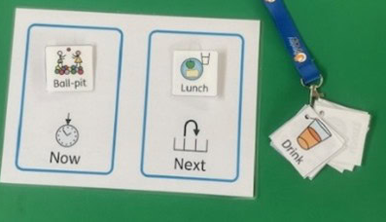
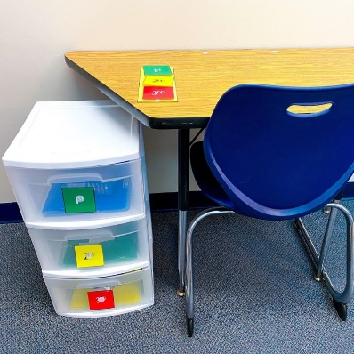

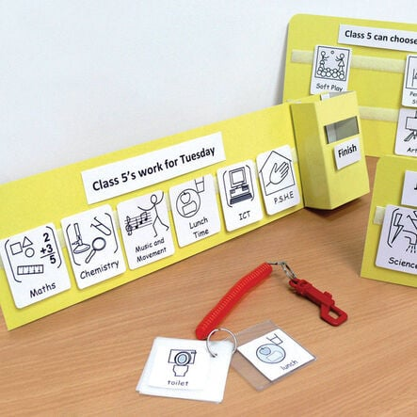
Visuals used throughout the day

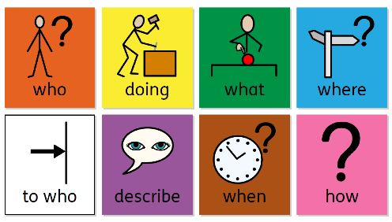
Colourful Semantics
Clear workspaces
Appropriate environment
Visual schedules



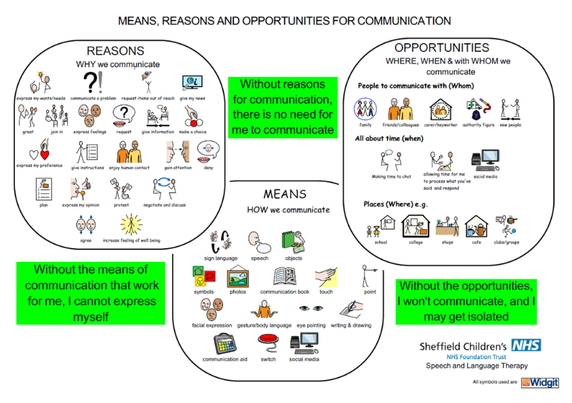


Short, engaging tasks
Clear language

Processing time
Communication approach

- Communication strategies
Communicating with children who have developed language:
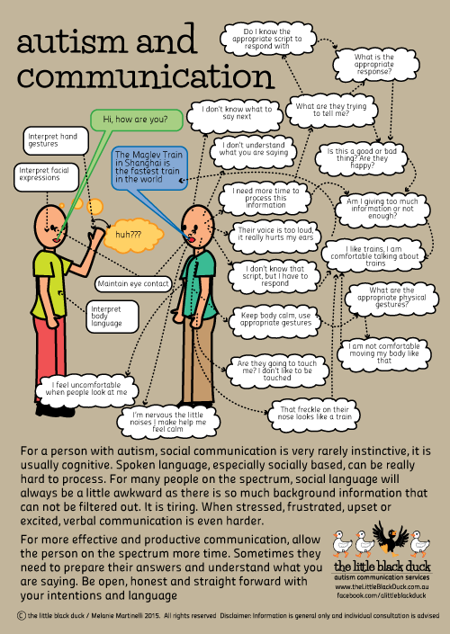

Communicating with children who are developing spoken language
Pre-Verbal children – the developmental stage before spoken language. Children will intentionally communicate through other means such as gestures, eye contact, sounds etc and are mostly expected to develop speech
Non-speaking children – the child does not form or utter spoken words. The child may be able to communicate through other means such as visuals, signing, drawing, or AAC devices
The image below shows how we can communicate with children who are at this stage as their language develops
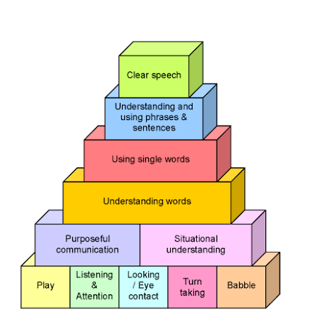


Setting | Curriculum | Assessment | Evidence
Launch  Pathway 1  Pre-Formal | AAE Curriculum | AAE Framework: Communication & Interaction,  Speaking & Listening Reading, Writing, Maths | Evidence for Learning
Lift off  Pathway 2  Semi-Formal | AAE Curriculum | AAE Framework Tracker  (as above, including Pre-KS1 standards) | Evidence for Learning
Ascent  Pathway 3  Specialist Resource Provision (SRP) | Adapted National Curriculum with the addition of:  - Life Skills  - Self-Care  - Physical Development | Pre Ks1 Standards  Birmingham Toolkit | Books
Orbit  Pathway 4  Mainstream | Adapted National Curriculum with the addition of:  - Interventions | Year group tracking  Birmingham Toolkit | Books
Reporting | Termly SEND Report to include:  - Numbers of children  - Attendance  - Curriculum assessment (Better than expected, Expected, Less than expected)
Section 6 – Curriculum & Assessment Overview

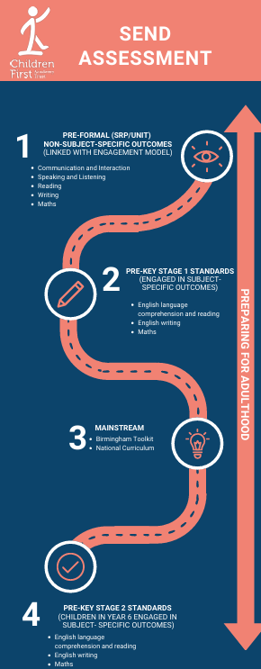

Section 7 – Monitoring and Quality Assurance
Setting | QA | Suggested Frequency | Who
Pre-Formal | SEND specific learning walks  EfL monitoring  Parent voice  IEP and Annual Reviews  Planning and continuous provision  Environment QA  Curriculum QA | Fortnightly  Fortnightly  When appropriate  When appropriate  Fortnightly  Fortnightly | SENCO  SLT  HT  Subject leads
Semi-Formal | SEND specific learning walks  EfL monitoring  Parent voice  IEP and Annual Reviews  Planning and continuous provision  Environment QA | Fortnightly  Fortnightly  When appropriate  When appropriate  Fortnightly  Fortnightly | SENCO  SLT  HT  Subject leads
Specialist Resource Provision (SRP) | SEND Book looks  SEND specific learning walks  Pupil voice  Parent voice  IEP and Annual Reviews  Adapted planning QA  Environment QA | Fortnightly  Fortnightly  When appropriate  When appropriate  When appropriate  Fortnightly  Fortnightly | SENCO  SLT  HT  Subject leads
Mainstream | SEND Book looks  SEND specific learning walks  Pupil voice  Parent voice  IEP and Annual Reviews  Adapted planning QA  Environment QA | Fortnightly  Fortnightly  When appropriate  When appropriate  When appropriate  Fortnightly  Fortnightly | SENCO  SLT  HT  Subject leads

Appendix

- AAE curriculum
- SRP curriculum example
- Planning document
- PRICE handling
- Entry and exit criteria
- Behaviour appendix
- AP rationale
- Staff Handbook

