
1. Aims
Behaviour
Policyr
Policy
Reviewed: September 2022
Next review date: September 2027

At Eldon School our behaviour policy aims to ensure that we have a caring, secure and orderly community in which the boundaries of acceptable behaviour are clear, shared and consistent, and reflect Government legislation as represented in the Education Act 2002 (amended 2011) and The Education and Inspection Act 2006 section 89.

At Eldon we believe;

- It is the right of every child at Eldon Primary School to feel safe and secure at school and have the opportunity to enjoy learning without distraction from others.

- It is the right of every teacher and adult at Eldon Primary School to be able to teach without obstruction and to work in a mutually respectful and professional environment.

- It is the right of every parent to know that their child is safe, treated fairly and will be supported to develop the skills to enable them to engage positively in our community.

The Behaviour policy operates in conjunction with the following policies:
- Anti-bullying policy
- Exclusion Policy
- Special Educational Needs (SEN)
- Attendance Policy
- Safeguarding and Child protection policy
- Positive Handling Policy

2. The Principles Underlying our Policy

We believe that good behaviour is the key to a good education. We believe in the principles of ‘positive’ behaviour management.

The school environment plays a central role in the children’s social and emotional development. Adults encountered by the children at school have an important responsibility to model high standards of behaviour at all times. At Eldon Primary School we reward positive rather than emphasise negative attitudes to behaviour and work. Therefore, the policy is based on a system of simple rewards and sanctions that are easily understood. We work towards standards of behaviour that are based on the principles of our Eldon values; respect, honesty and kindness. Our expectation is that everyone in the school community aims to demonstrate this behaviour at all times by following a simple set of ‘Eldon Rules (appendix 1).
An effective whole school policy requires:
• Consistency- everybody to follow it
• Effective classroom management and practice
• Positive relationships
• Motivating steps to achievement
• Clear rewards and sanctions

Why Positive Behaviour Management?
In the world around them children see many different examples of how people behave. We have a responsibility to help children understand that they have choices about how to behave and help them develop the strategies to make appropriate choices. Our aim is to create an environment where children feel; valued, safe and motivated to learn. We believe that good behaviour and discipline are the foundation of all learning, and without a calm, orderly atmosphere effective teaching and learning cannot take place.
We believe that children respond best to praise and encouragement, we therefore use positive reframing e.g. say ‘walking quietly thank you’, instead of ‘why are you talking?’​
Research has shown that the majority of off task behaviour in schools is non-disruptive. Simple redirecting techniques can bring children back on task very quickly, reducing the need for formal ‘warnings’.
The ‘Look’ ... giving a look that says ‘I’m aware of your behaviour and disapprove’ is an effective way of redirecting off task behaviour.
Proximity Praise ... another way to redirect a child back on task is to focus on the appropriate behaviour of those around him.
Redirecting ... just mentioning a child’s name when you are teaching may be enough to redirect him back to task.
Physical Proximity ... redirect a child back on task simply by walking over and standing close by, the child will know why you have arrived at his side and will respond.
Take Up Time ... avoid confrontation, allow the child time to think.
As soon as a child is back on task, advantage should be taken of opportunities to praise his/her behaviour.

3. The Policy

All of the expectations of our policy are based on our ‘Eldon Rules’:
Aspiration, Determination in a culture of Respect.
- Respect yourself. Keep yourself healthy and safe.
- Respect everyone’s right to be safe from harm or discrimination. Be kind to everyone.
- Respect everyone’s differences. Be accepting of difference.
- Respect everyone’s right to learn. Make good use of learning time.
- Respect the truth. Be honest.
- Respect the environment. Be proud of your school and the world around you.

These rules are on display around the school and in each class. Teachers use these rules to discuss and reinforce the expectations we have whenever behaviour is being discussed.

3.1 In the Classroom

Successful teachers have a minimal number of rules which are in effect at all times; in all activities; all day long. School rules and any classroom rules must be clearly displayed in each classroom.
All rules need to be explained, taught and reviewed regularly. This should be done in assemblies and in ‘circle time’ and when any warnings are given – ‘which of the school rules have you broken?’
Each class has a behaviour chart displayed in the classroom. The chart is divided into sections – green, yellow, orange, red. Every child’s name is displayed on the chart. Every child starts every session (EYFS and KS1 every lesson) on green. If children are not following the Eldon or class rules, children should be given a verbal reminder, if this does not lead to a change in behaviour sanctions are given as follows:

- 1st warning - name moved down onto orange, explanation of why given
- 2nd warning - name moved down again, explanation of why given
- 3rd warning - sent to partner class with work - KS2 (KS1 time out in the C/R). Orange slip completed.
- 4th warning - Sent to YLs or AHTs and a red slip is completed. Parents will be informed and the red incident recorded, an internal exclusion may be considered.

Children who improve their behaviour following warnings should be moved back to green on the chart as soon as they return to class, although the sanction must still be recorded.

There may be occasions when the behaviour is so serious that the initial consequences do not apply, therefore the child will be moved to red and sent to a member of SLT and they will liaise with parents as necessary in order to agree appropriate sanctions and support required. The same plan and support will put into place for children who are having to leave class regularly – more than 3 times in a half term - and the class teacher will speak to parents. Any more incidents will be dealt with by the YL or SLT.

Racist, homophobic, sexist and discriminatory incidents will not be tolerated and are dealt with by SLT. Parents will be informed of all such incidents and sanctions such as internal exclusion and lunchtime reflections will be applied.

Exclusion (internal and external) will be considered by SLT in cases of; extreme or persistent disrespectful behaviour, discriminatory behaviour, dangerous behaviour or bullying.

3.2 Classroom Rewards

Positive recognition reduces unwanted behaviour and motivates children. Positive recognition is the most important part of the policy. Praise is the most meaningful, effective positive recognition we can give. Praise can be individual or at a whole class level. Class teachers use reward systems as appropriate in the classroom:
- Table points
- Lucky Dip
- Extra playtime
- Marble jars
- Certificate to take home

3.3 Whole School rewards

Star of the week / Values Assembly
KS1- Every week the teacher decides who to choose for the Eldon Star of the week. They may be rewarded with a certificate and a reward in class e.g. special chair, item of clothing (e.g. a crown/tiara). Children should be encouraged to feel proud of this achievement and should keep the reward all week.

KS2 - Teachers choose an Eldon Star of the week each week – this can be for a particularly good piece of work, being helpful, following all our values and rules etc. This information is recorded on the proforma provided. These sheets are given to the designated teachers no later than Thursday evening. Each teacher is provided with special metallic stickers to be used for Eldon Stars of the week and a trophy. Children should be encouraged to feel proud of the achievement and should keep the sticker visible all day. On Friday morning before assembly class teachers award their star with the special metallic sticker and ensure all the class know why that child has been chosen. Teachers should aim to choose different children each week

During Friday morning’s assembly the assembly leader will ask the Eldon Stars of the week to stand up to be applauded. At the end of assembly each star will receive a pencil and a badge. Each week the stars names will be placed in a golden box. A name from each year will be drawn out. Those picked will receive a £1 voucher for the school shop. At the end of each half term there will be a super draw where all the names of the stars for the whole of that half term are placed in a box and one super star is picked out to receive a ‘super prize’ which is chosen from a catalogue compiled from children’s ideas (via school council)

KS2- Special mentions should be discussed in year teams meetings and written on the proforma provided. Chosen children should be mentioned weekly during year assemblies. They are also given a special Eldon Primary School sticker and their name displayed in the hall.

Certificate assemblies
KS2- Certificates are presented half-termly. Nominations should be discussed during a year team meeting. Certificates should be attractively printed and placed on the stage prior to Certificate assembly. Five children for each year team may be nominated for each category:
- improvement
- achievement
- citizenship
- handwriting

Cups and certificates are presented monthly to the classes which have the:
- Best attendance
- Least number of lates
- Least number of behaviour incidents
- Most improved
- Super cup - Most points overall (KS2)

Certificates are awarded to the classes which have the:
- Most improved lates
- Most improved lunchtime incidents

The balloon is an on-going race to recognise the class with highest attendance and the best turned out!

KS1 Certificates are presented weekly to the classes which have the:
- best attendance
- least number of lates

4. Lunchtimes

Playtime is very important for children. It is expected that the children will follow the “Eldon Rules” at all times. Fighting and bullying of any kind will not be tolerated. It is of utmost importance that all staff take children’s concerns seriously. In every situation where a child complains about another, the two children should be brought together and given the chance to explain what has happened.

If children are not following the school rules at lunchtime, they are sent to a ‘Time Out Zone’. There the incidents are followed up by a Learning mentor or designated lunchtime supervisor and the child will be told to stay in the Time Out Zone for a period of time. AHTs will follow up serious or repeated lunchtime behaviour problems, these children may be asked to stay inside for a set period of time. AHTs will liaise with parents.

Inside, children may be asked to complete an ERR form (everyone’s right to reply) this enables them to reflect on what happened; why it happened; what they should have done; what they can do to make things better and whether they will need any help. They will be asked to reflect on which rule they have not followed and supported with strategies to manage the behaviour if required (see appendix 3).

If children receive 3 or more periods inside for serious behaviour incidents, parents will be informed. If there is no improvement, parents are asked to come into school to discuss the incidents and plan any future steps that need to be taken. In some cases, children may receive lunchtime exclusions for a period of time. Lunchtime supervisors have regular half termly meetings with the Deputy Headteacher.

5. Break Times

Children who are involved in unacceptable behaviour during playtime may be sent to stand by a teacher on duty who will note the incident. If very serious they may be sent inside. Year leaders will be informed of behaviour incidents that need recording. AHTs will be informed of regular incidents and reflection may be needed (see appendix 3).

Children who have not completed classwork due to behaviour incidents for which they have been sent to another class can be kept in to finish this at break time. If they complete the work they go out.

6. Vulnerable Pupils

During their time at school some pupils will require extra support in managing their behaviour. At these times, the behaviour strategy may need to be adapted to support the pupil. These pupils will have an individual behaviour plan and pastoral support from learning mentors, senior staff, ELSA trained staff (Emotional Literacy support Assistants) or Place2Be.

Any exclusions will be undertaken following the Enfield Exclusion Guidelines. On returning to the school, a plan will be developed to support the pupil’s reintegration into the classroom.

There are three Learning Mentors working across the school. Learning Mentors are available to talk with vulnerable children about their behaviour and to work alongside them in the classroom. All children may ask to speak to them if they have any worries or concerns. They may also be referred to the Learning Mentors by their teacher. Two mentors are ELSA trained (Emotional Literacy support Assistants) and run programmes designed to support children with SEMH difficulties).

Individual target cards are available from AHTs to help particular children focus on aspects of their own behaviour which need improving.

Referrals can also be made to external agencies such as Behaviour Support Service, when deemed necessary. Circles of friends can be set up within the classroom.

6.1 Learning Mentor and mentoring

Aims:
- To identify and remove the barriers to learning that prevent individuals achieving their full potential
- To promote inclusion
- To develop a holistic approach to children’s education where emotional and social growth and academic achievement are all equally valued

Process:
- Referral is made using the TAC form.
- A learning mentor or ELSA then makes an appointment to see the child’s parent/carer and class teacher where observations and concerns are discussed.
- An appointment is also made to see the child. Here the mentor lays foundations for a good relationship.
- A programme of intervention is designed or run.
- Mentoring programme begins.
- Programme is then reviewed and parents informed.

- School Visits and Events

Some children may need individual support on school visits. This support should be agreed between the class teacher, SLT and where appropriate parents. The support should be clear on risk assessments undertaken prior to the visit. Parents may be asked to escort their child if the child’s behaviour is a cause for concern.
- Record Keeping

The class teacher should keep a record of Orange and red incidents (sent out of class) indicating what the warnings were for using a simple code e.g. NFI – not following instructions.

Red slips indicating 4 warnings must go to the AHT with date and reasons.

Teachers should keep a record of children sent on orange. Teachers will see parents if there are 3 incidents in half term.

All orange and red slips are given to Ms Gold and these are logged onto scholar pack.

Each term AHTs analyse the recorded incidents and plan further individual support for those children or groups who are over represented.

- Circle Time

All classes should have a regular circle time to discuss any issues and to discuss the school values and ethos. This may take place either in the classroom, in the hall or in the garden.

Appendix 1

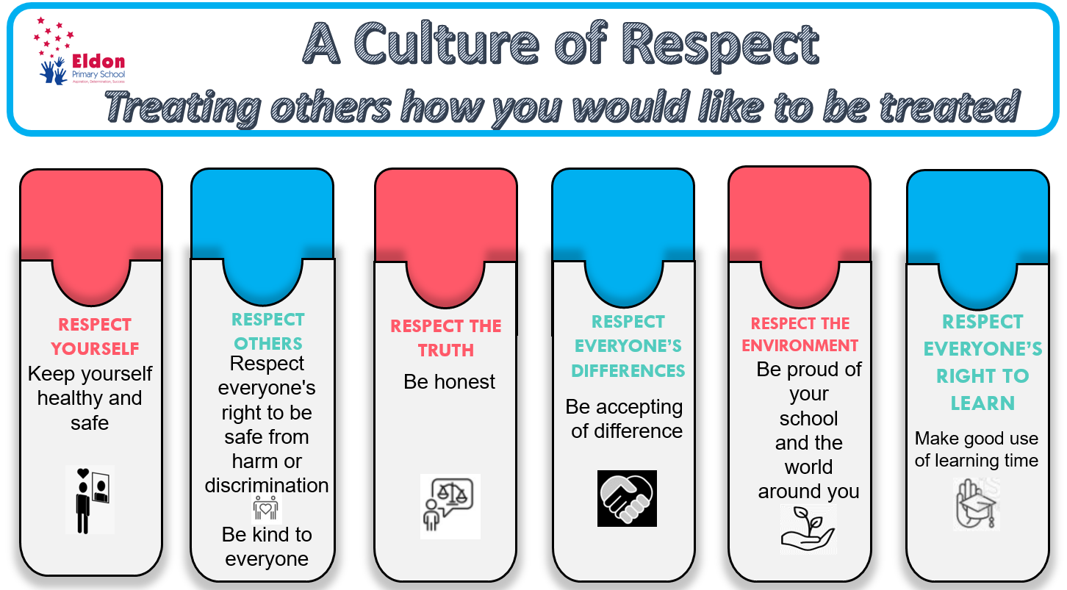

Appendix 2
Stay on Green
Outstanding learning behaviour

Excellent learning behaviour

You are learning and behaving well
Thank you

First warning

Second warning

Please leave and go to our partner classroom and complete your learning. If you do not complete your learning you will need to do so at break

You need to go to the Assistant Headteacher/Year Leader and you may need some time out of our classroom

Appendix 3 Reflection or Time Out

During ‘Reflection Time’ or ‘Time Out’
Staff will;
- Recognise that when children are in the RED zone they need time to cool down before they can reflect.

- Have the school rules to hand all the time to refer to them. Make the language in the rules the language used to reflect on the behaviour.

- Use the ‘Everyone’s Right to Reply’ forms with the child as a scaffold. How can you fix it?

- Use social stories where required to support children’s understanding

- Remember that some children need scaffolding or an individual approach for their behaviour, like they do for their learning

- Remember that children need consequences, but we need to give them a way back, be careful with an 'in the moment' excessively harsh consequences.

- Remember that behaviour is not the total sum of who the child is.

- Ask themselves ‘What is going on for this child?’

- Take the grey days with the great days!

Appendix 4 Eldon Child

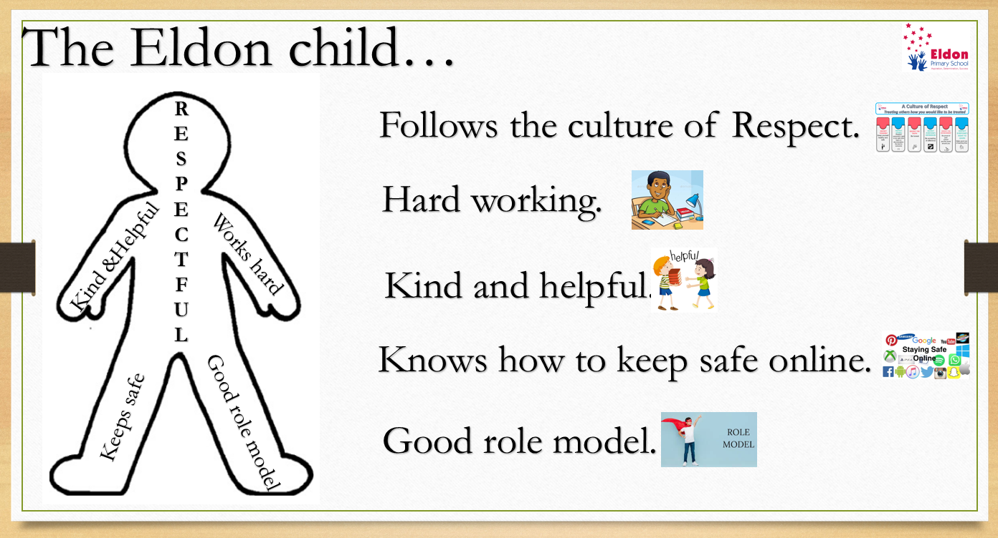

Appendix 5 Zones of Regulations – Emotional regulation



