
MFL 2024- 2025

 | Autumn 1 | Autumn 2 | Spring 1 | Spring 2 | Summer 1 | Summer 2
EYFS
Y1
Y2
Y3 | A new start  Say a greeting  Respond to a question about name or feelings  Attempt a question – name or feelings  Remember some numbers between 0-11  Say at least 4 colours   | Calendar and celebrations  Read and say some adjectives of colour  Recognise and say a day of week  Attempt to copywrite accurately a day of week  Recognise and say most months  Attempt to write accurately an important month of year   | Animals I like and don’t like  Remember and say animal nouns  Write a simple sentence about a favourite animal  Recognise a noun in a sentence  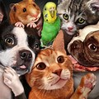 | Carnival and using numbers  Recall numbers 0-11  Recall personal info questions from Autumn 1  Say age  Recall some months of year  Recall some days of week  Attempt to say and write the date  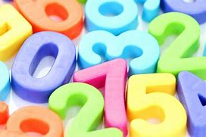 | Fruits, vegetables, hungry giant story  Understand and say fruit/veg nouns  Recall numbers 0-15  Count fruits  Understand, enjoy, join in with story and board game  Ask politely for an item  Attempt to write a simple sentence using conjunction “and”  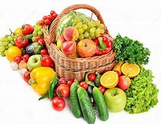 | -Going on a picnic  -Aliens in France  -Language puzzle  Identify and understand familiar colours in a sentence  Remember and say familiar colours  Understand and join in with a story  Ask the question “Where do you live/  Respond to the question with “I live in...”  
Y4 | A new start  Say a greeting  Respond to a question about name or feelings  Attempt a question – name or feelings  Remember some numbers between 0-11  Say at least 4 colours | Calendar and celebrations  Read and say some adjectives of colour  Recognise and say a day of week  Attempt to copywrite accurately a day of week  Recognise and say most months  Attempt to write accurately an important month of year | Animals I like and don’t like  Remember and say animal nouns  Write a simple sentence about a favourite animal  Recognise a noun in a sentence | Carnival and using numbers  Recall numbers 0-11  Recall personal info questions from Autumn 1  Say age  Recall some months of year  Recall some days of week  Attempt to say and write the date | Fruits, vegetables, hungry giant story  Understand and say fruit/veg nouns  Recall numbers 0-15  Count fruits  Understand, enjoy, join in with story and board game  Ask politely for an item  Attempt to write a simple sentence using conjunction “and” | -Going on a picnic  -Aliens in France  -Language puzzle  Identify and understand familiar colours in a sentence  Remember and say familiar colours  Understand and join in with a story  Ask the question “Where do you live/  Respond to the question with “I live in...”
Y5 | Welcome to school  Answer several questions about themselves  ask several questions about a friend  understand and respond to classroom instructions  recall days of week  recall months of year  say and write some nouns for places in school  say and write some nouns for classroom objects   | My town, your town  Listen and respond accurately to sequence of commands  Communicate simple instructions  Recognise and read places in town nouns  Ask and respond appropriately to where something is  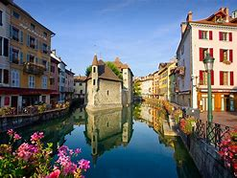 | Family tree and faces  Remember and say nouns for members of family  Recognise, understand and say parts of face nouns  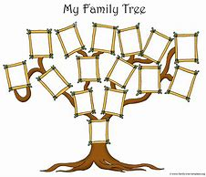  Write a simple sentence with a part of face and a colour. | Face and body parts  Recognise and use accurately body part nouns  Understand simple descriptive sentence about body parts with colour adjectives and size adjectives  Say and write simple sentence about for a physical description  Follow a simple sequence of physical movement commands  Communicate a simple sequence of physical movement commands  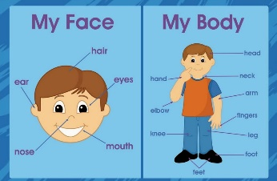 | -Feeling unwell  -Jungle animals  Recall body part nouns  Explain what hurts and how feeling  Take part in at the doctors’ roleplay  Identify jungle animal nouns  Remember jungle animal nouns  Identify and find meaning of unfamiliar adjectives  Understand and join in with a story.  Say/write a simple sentence – noun, adjective, conjunction about jungle animals.  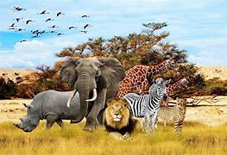 | -The weather  -Ice creams  -Language Puzzle  Read and understand 3 simple sentences about the weather  Say and write 3 simple sentences about the weather  Understand some ice cream flavours  Describe a favourite ice cream  Participate in a buy an ice cream roleplay  
Y6 | Talking about Us  Say an extended sentence about how feeling with a reason  Say a 3rd person singular sentence with details about someone else  recognise and say at least 5 school subjects  say and write an extended opinion about a school subject using a like/dislike verb  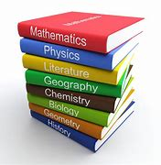 | Time in the city  Understand at least 5 places in the city/town nouns  Say and write a simple sentence to describe what is in a town/city  Can say and write the nouns for presents on a charity stall.  Can ask and answer politely to purchase an item  Can participate in a simple shopping dialogue  Write a simple descriptive sentence about a festive jumper.  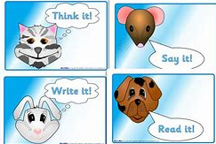 | Healthy eating and going to the market  Remember and say familiar fruit/veg nouns  Identify cognates and semi cognates (fruit/veg nouns)  Say some numbers between 0 and 100 Participate in an at the market roleplay  Follow simple instructions for a recipe  Give simple instructions for a recipe  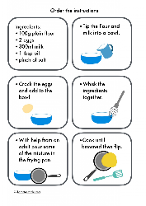 | Clothes  Identify and understand clothes nouns  Can say nouns for clothes accurately  Can read and understand descriptive sentences about clothes  Can use nouns and adjectives accurately to create descriptive sentences  Can use parts of the verb to wear to write simple clothes descriptions  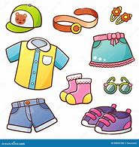 | Out of this World  Understand information on a simple ID card  Ask and answer details about identity  Recognise planets in target language  Use adjectives accurately to describe planets  Read and understand simple facts about the planets.  Recall and use prior learning to create a simple imaginary planet description.   | Going to the seaside  Language Puzzle  Understand and say nouns for beach bag items  Use sentence starters to create a sequence of sentences  Use “you can” + infinitive of a verb to create a persuasive sentence  Say/write extended sentences to describe a day at the seaside.  

