Design & Technology 2024-2025
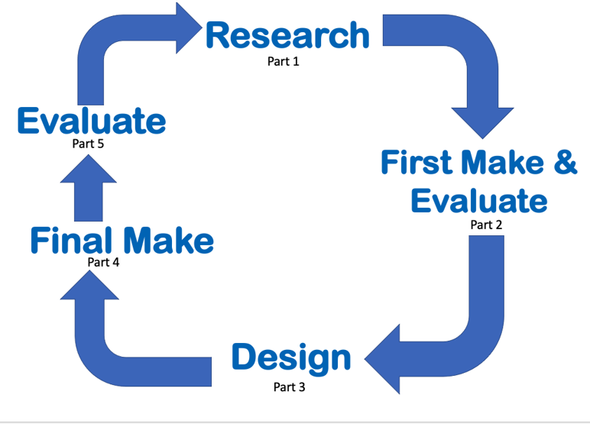  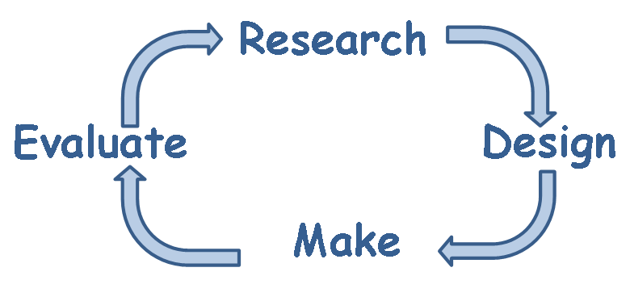  Teaching Cycle |  |  | Overview of Topics  Food  Textiles  Mechanisms  Structures  Electrical Systems
 | Autumn | Spring |  | Summer
EYFS | Textiles – Collage  - Practise basic cutting, tearing and joining skills.  - Select from and use a range of materials  Food – Preparing vegetables (The Enormous Turnip)  - use the principles of a healthy and varied diet to prepare dishes. | Mechanisms – Creating simple mechanisms (flip flap safari).  - design purposeful, functional, appealing products for themselves  -select from and use a range of tools and equipment to perform practical tasks [for example, cutting and joining]  Structures – Create 3D structures (bus/ transport)  - design purposeful, functional, appealing products for themselves  - select from and use a range of tools and equipment to perform practical tasks [for example, cutting, shaping, joining and finishing] |  | Food – Fruit Kebabs (The Hungry Caterpillar)  - use the principles of a healthy and varied diet to prepare dishes.  Structures – Create 3D structures (Into the Woods)  - design purposeful, functional, appealing products for themselves  - select from and use a range of tools and equipment to perform practical tasks [for example, cutting, shaping, joining and finishing]
EYFS | Continuous Provision:  Structures – Exploring and creating structures. (Knowledge: To understand and recognise different types of structures.)  Food – Preparing food. (Knowledge: To understand what is healthy and unhealthy and what their likes and dislikes are. Exploring different tastes.)  Textiles – Threading and weaving. (Knowledge: To understand how material can join to make an object.)
Y1 | Autumn 1  Food – Sandwich preparation.  - Identifying food groups and where food comes from.  - use the principles of a healthy and varied diet to prepare dishes.  Knowledge: To understand how to make a healthy sandwich, making appropriate choices based on healthy ingredients. | Spring 2  Textiles – Stitching: Templates and joins.  - design purposeful, functional, appealing products for themselves and other users based on design criteria  - select from and use a wide range of materials and components, including construction materials, textiles and ingredients, according to their characteristics  - evaluate their ideas and products against design criteria  Knowledge: To understand the purpose of a puppet and how it moves, learning how to join templates and use simple stitches. |  | Summer 2  Mechanisms – Sliders and levers.  - design purposeful, functional, appealing products for themselves and other users based on design criteria  - generate, develop, model and communicate their ideas through talking, drawing, templates, mock-ups and, where appropriate, information and communication technology  -select from and use a range of tools and equipment to perform practical tasks [for example, cutting, shaping, joining and finishing]  -select from and use a wide range of materials and components, including construction materials, textiles and ingredients, according to their characteristics  - evaluate their ideas and products against design criteria  explore and use mechanisms [for example, levers, sliders, wheels and axles], in their products.  Knowledge: To understand the motion of a moving picture and use a slider and lever to create their own.
Y2 | Autumn 2  Structures – Joining to make freestanding structures (jinx joints).  - design purposeful, functional, appealing products for themselves and other users based on design criteria  - generate, develop, model and communicate their ideas through talking, drawing, templates, mock-ups and, where appropriate, information and communication technology  - select from and use a range of tools and equipment to perform practical tasks [for example, cutting, shaping, joining and finishing]  - evaluate their ideas and products against design criteria  - build structures, exploring how they can be made stronger, stiffer and more stable  Knowledge: To understand the features of a doll house, design their own dolls house in the style of a Tudor house, creating a jinx joint and simple hinge for a door/window. | Spring 1  Food – Preparing vegetables (soup).  - use the principles of a healthy and varied diet to prepare dishes.  - understand where food comes from.  Knowledge: To understand what makes a soup healthy. Select from a range of vegetables and understand where they come from if they are not in season. |  | Summer 1  Mechanisms – Wheels and axles.  - design purposeful, functional, appealing products for themselves and other users based on design criteria  - generate, develop, model and communicate their ideas through talking, drawing, templates, mock-ups and, where appropriate, information and communication technology  - select from and use a range of tools and equipment to perform practical tasks [for example, cutting, shaping, joining and finishing]  -select from and use a wide range of materials and components, including construction materials, textiles and ingredients, according to their characteristics  - explore and evaluate a range of existing products  - evaluate their ideas and products against design criteria  - explore and use mechanisms [for example, levers, sliders, wheels and axles], in their products.  Knowledge: To understand how a vehicle moves using wheels and axles.
Y3 | Autumn 1  Structures – Hinges on a structure.  - use research and develop design criteria to inform the design of innovative, functional, appealing products that are fit for purpose, aimed at particular individuals or groups  - select from and use a wider range of tools and equipment to perform practical tasks [for example, cutting, shaping, joining and finishing], accurately  - investigate and analyse a range of existing products  - evaluate their ideas and products against their own design criteria and consider the  - views of others to improve their work  - apply their understanding of how to strengthen, stiffen and reinforce more complex structures  Knowledge: To understand the structure needed for a box and how to create a hinge joint. | Spring 1  Mechanisms – Levers and linkage.  - use research and develop design criteria to inform the design of innovative, functional, appealing products that are fit for purpose, aimed at particular individuals or groups  - generate, develop, model and communicate their ideas through discussion, annotated sketches, cross-sectional and exploded diagrams, prototypes, pattern pieces and computer-aided design  - select from and use a wider range of tools and equipment to perform practical tasks [for example, cutting, shaping, joining and finishing], accurately  - select from and use a wider range of materials and components, including construction materials, textiles and ingredients, according to their functional properties and aesthetic qualities  - investigate and analyse a range of existing products  - evaluate their ideas and products against their own design criteria and consider the views of others to improve their work  - understand how key events and individuals in design and technology have helped shape the world  - understand and use mechanical systems in their products [for example, gears, pulleys, cams, levers and linkages]  Knowledge: To understand the motion of a moving picture book and use levers and linkages to create their own. |  | Summer 1  Textiles – Stitching: 2D to 3D joins.  - use research and develop design criteria to inform the design of innovative, functional, appealing products that are fit for purpose, aimed at particular individuals or groups  - generate, develop, model and communicate their ideas through discussion, annotated sketches, cross-sectional and exploded diagrams, prototypes, pattern pieces and computer-aided design  - select from and use a wider range of materials and components, including construction materials, textiles and ingredients, according to their functional properties and aesthetic qualities  - investigate and analyse a range of existing products  - evaluate their ideas and products against their own design criteria and consider the views of others to improve their work  Knowledge: To understand how materials are joined to create an item that can contain objects (pencils/money). Understanding how to create templates of 2D shapes then join to make a 3D shape.
Y4 | Autumn 2  Structures – Load bearing structures (frames).  - use research and develop design criteria to inform the design of innovative, functional, appealing products that are fit for purpose, aimed at particular individuals or groups  - select from and use a wider range of materials and components, including construction materials, textiles and ingredients, according to their functional properties and aesthetic qualities  - understand how key events and individuals in design and technology have helped shape the world.  - apply their understanding of how to strengthen, stiffen and reinforce more complex structures  Knowledge: To understand how a bridge structure will support weight to make it a load bearing structure. | Spring 2  Electrical Systems – Circuits and switches.  - generate, develop, model and communicate their ideas through discussion, annotated sketches, cross-sectional and exploded diagrams, prototypes, pattern pieces and computer-aided design  -select from and use a wider range of materials and components, including construction materials, textiles and ingredients, according to their functional properties and aesthetic qualities  -investigate and analyse a range of existing products  -understand how key events and individuals in design and technology have helped shape the world  - understand and use electrical systems in their products [for example, series circuits incorporating switches, bulbs, buzzers and motors]  Knowledge: To understand how a simple circuit is created and use it to make a light up device. |  | Summer 2  Food – Healthy and varied diet (vegetable curry).  - understand and apply the principles of a healthy and varied diet  - understand seasonality, and know where and how a variety of ingredients are grown, reared, caught and processed.  Knowledge: To understand what ingredients are used to make a healthy curry and explore a range of vegetables and spices.
Y5 | Autumn 2  Food – Celebrating cultures and seasonality (creating a biscuit.)  - Prepare and cook a variety of predominantly savoury dishes using a range of cooking techniques.  - Prepare and cook a variety of predominantly savoury dishes using a range of cooking techniques  Knowledge: To understand what ingredients are needed to create different textured biscuits. To understand that biscuits can be sweet or savoury and the process of baking. | Spring 2  Mechanisms – Cams, wheels and axles.  - use research and develop design criteria to inform the design of innovative, functional, appealing products that are fit for purpose, aimed at particular individuals or groups  - generate, develop, model and communicate their ideas through discussion, annotated sketches, cross-sectional and exploded diagrams and prototypes  - select from and use a wider range of tools and equipment to perform practical tasks [for example, cutting, shaping, joining and finishing], accurately  - select from and use a wider range of materials and components, including construction materials according to their functional properties and aesthetic qualities  - investigate and analyse a range of existing products  - evaluate their ideas and products against their own design criteria and consider the views of others to improve their work  - understand and use mechanical systems in their products [for example, gears, pulleys, cams, levers and linkages]  Knowledge: To understand what a moving toy needs and use cams, wheels and axles to make a moving toy. |  | Summer 2  Textiles – Stitching: joining different fabrics  - generate, develop, model and communicate their ideas through discussion, annotated sketches, cross-sectional and exploded diagrams, prototypes, pattern pieces and computer-aided design  - select from and use a wider range of materials and components, including construction materials, textiles and ingredients, according to their functional properties and aesthetic qualities  - investigate and analyse a range of existing products  - evaluate their ideas and products against their own design criteria and consider the views of others to improve their work  - understand how key events and individuals in design and technology have helped shape the world  Knowledge: To understand what the purpose and features of a bag. Use more complex stitches to ensure it secures different fabrics.
Y6 | Autumn 1  Breads: different types. -Prepare and cook a variety of predominantly savoury dishes using a range of cooking techniques  Knowledge: To understand that breads can be sweet or savoury. To know that bread can be served in a variety of ways. |  |  | Summer 2  Food – Celebrating cultures.  Textiles and Electrical Systems– Stitching, monitoring and controlling  - investigate and analyse a range of existing products  - use research and develop design criteria to inform the design of innovative, functional, appealing products that are fit for purpose, aimed at particular individuals or groups  - generate, develop, model and communicate their ideas through discussion, annotated sketches, cross-sectional and exploded diagrams, prototypes, pattern pieces and computer-aided design  - evaluate their ideas and products against their own design criteria and consider the views of others to improve  - select from and use a wider range of tools and equipment to perform practical tasks [for example, cutting, shaping, joining and finishing], accurately  - select from and use a wider range of materials and components, including construction materials, textiles and ingredients, according to their functional properties and aesthetic qualities  - understand and use electrical systems in their products  - apply their understanding of computing to program, monitor and control their products.  Knowledge: To understand how to use computing to create a toy that makes sound.

