Science 2024- 2025
 | Autumn 1 | Autumn 2 | Spring 1 | Spring 2 | Summer 1 |  | Summer 2
EYFS | Birth – 3 years  - Explore materials with different properties  - Explore natural materials, indoors and outdoors  - Explore and respond to different natural phenomena in their setting and on trips  - Make connections between the features of their family and other families  - Notice differences between people.  3 years – 4 years.  - Use all their senses in hands-on exploration of natural materials.  - Explore collections of materials with similar and/or different properties.  - Talk about what they see, using a wide vocabulary.  - Explore how things work.  - Plant seeds and care for growing plants.  - Understand the key features of the life cycle of a plant and an animal.  - Begin to understand the need to respect and care for the natural environment and all living things.  - Explore and talk about different forces they can feel.  - Talk about the differences between materials and changes they notice.
Reception | Development matters (non-statutory)  - Explore the natural world around them.  - Describe what they see, hear and feel whilst outside.  - Recognise some environments that are different to the one in which they live.  - Understand the effect of changing seasons on the natural world around them.  ELGs (Statutory)  - Explore the natural world around them, making observations and drawing pictures of animals and plants.  - Know some similarities and differences between the natural world around them and contrasting environments, drawing on their experiences and what has been read in class.  - Understand some important processes and changes in the natural world around them, including the seasons and changing states of matter.
Y1 | 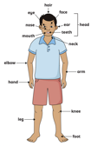  Animals including humans.  To identify, name, draw and label the basic parts of the human body and say which part of the body is associated with which sense.  Working scientifically:  - Asking simple questions and recognising that they can be answered in different ways.  - Using their observations and ideas to suggest answers to questions.  - Performing simple tests.    Enquiry type: Pattern seeking.  Seasonal change – weather and plants (autumn).  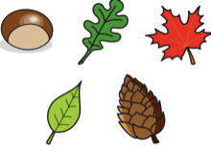  To observe and describe weather associated with the seasons and how day length varies.  Working scientifically:  - Gathering and recording data to help in answering questions.  - Asking simple questions and recognising that they can be answered in different ways.  Enquiry type: observing over time.    Plants  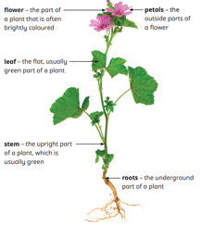  Identify and describe the basic structure of a variety of trees.  Working Scientifically:  - Identifying and classifying.    Enquiry type: identifying, classifying and grouping. | Animals including humans.  To identify and name a variety of common animals including fish, amphibians, reptiles, birds and mammals.  To identify and name a variety of common animals that are carnivores, herbivores and omnivores.  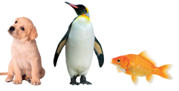  To describe and compare the structure of a variety of common animals (fish, amphibians, reptiles, birds and mammals including pets).  Working scientifically:  - Asking simple questions and recognising that they can be answered in different ways.  - Gathering and recording data to help in answering questions.  - Identifying and classifying.  - Using observations and ideas to suggest answers to questions.  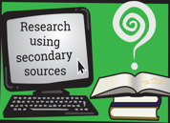  Enquiry type: research using secondary sources. | Seasonal change – weather (winter).  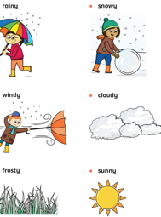  To observe changes across the four seasons.  Working scientifically:  - Asking simple questions and recognising that they can be answered in different ways.  - Gathering and recording data to help in answering questions.  Enquiry type: observing over time.  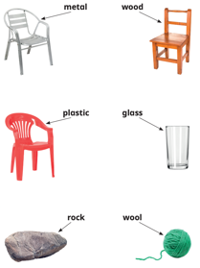  Materials.  To distinguish between an object and the material from which it is made.  To identify and name a variety of everyday materials.  To describe the simple physical properties of a variety of everyday materials.  To describe the simple physical properties of a variety of everyday materials.  To compare and group together a variety of everyday materials on the basis of their simple physical properties.  Working scientifically:  - Identifying and classifying.  - Observing closely, using simple equipment.  - Performing simple tests  - Gathering and recording data to help in answering questions.  - Using observations and ideas to suggest answers to questions.    Enquiry type: comparative and fair testing. |  | Seasonal change – weather and plants (Spring).  To observe changes across the four seasons.  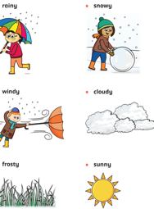  Working scientifically:  - Asking simple questions and recognising that they can be answered in different ways.  - Gathering and recording data to help in answering questions.  Enquiry type: observing over time.  Plants  To identify and name a variety of common wild and garden plants, including deciduous and evergreen trees.    To identify and describe the basic structure of a variety of common flowering plants, including trees.  Working scientifically:  - Observing closely, using simple equipment.  - Gathering and recording data to help in answering questions.  - Identifying and classifying.  - Using observations and ideas to suggest answers to questions.  Enquiry type: identifying classifying and grouping. |  | Seasonal change – weather and plants (summer).  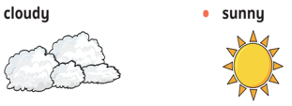  To observe changes across the four seasons.  Working scientifically:  - Asking simple questions and recognising that they can be answered in different ways.  - Gathering and recording data to help in answering questions.  Enquiry type: observing over time.  Animals including humans.  To identify and name a variety of common animals including fish, amphibians, reptiles, birds and mammals.  To identify and name a variety of common animals that are carnivores, herbivores and omnivores.  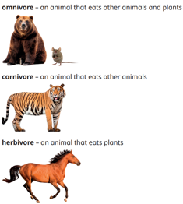  To describe and compare the structure of a variety of common animals (fish, amphibians, reptiles, birds and mammals including pets).  Working scientifically:  - Asking simple questions and recognising that they can be answered in different ways.  - Gathering and recording data to help in answering questions.  - Identifying and classifying.  - using observations and ideas to suggest answers to questions.  Enquiry type: research using secondary sources.
Y2 | 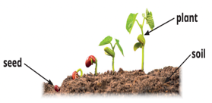  Plants  To observe and describe how bulbs grow into mature plants.  To find out and describe how plants need water, light and a suitable temperature to grow and stay healthy.  Working scientifically:  - Observing closely, using simple equipment.  - Asking simple questions and recognising that they can be answered in different ways.  - Performing simple tests.    Enquiry type: observing over time.  Living things and their habitats.  To explore and compare the differences between things that are living, dead and things that have never been alive.  Working scientifically:  - Identifying and classifying. | Living things and their habitats.  To identify and name a variety of plants and animals in their habitats, including micro-habitats.  To identify that most living things live in habitats to which they are suited and describe how different habitats provide for the basic needs of different kinds of animals and plants, and how they depend on each other.  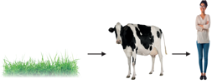  To describe how animals obtain their food from plants and other animals, using the idea of a simple food chain, identify and name different sources of food.  Working scientifically:  - Gathering and recording data to help in answering questions.  - Using their observations and ideas to suggest answers to questions.  - Identifying and classifying.  - Observing closely, using simple equipment.  - Gathering and recording data to help in answering questions.  Enquiry type: research using secondary sources. | Use of everyday materials.  To identify and compare the variety of everyday materials including wood, metal, plastic, glass, brick, rock, paper and cardboard for particular uses.  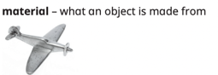  Working scientifically:  - Identifying and classifying  - Performing simple tests.  - Asking simple questions and recognising that they can be answered in different ways.  - Observing closely, using simple equipment.  - Using observations and ideas to suggest answers to questions.  Enquiry type: identifying, classifying and grouping. | Plants.  To observe and describe how seeds grow into mature plants (plant seeds).    Find out and describe how plants need water, light and a suitable temperature to grow and stay healthy.  Working scientifically:  - Observing closely, using simple equipment.  - Asking simple questions and recognising that they can be answered in different ways.  - Performing simple tests.    Enquiry type: observing over time. | Animals including humans.  To notice that animals, including humans, have offspring which grow into adults (SRE link).  To find out about and describe the basic needs of animals including humans for survival.  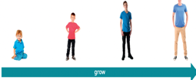  To describe the importance for humans of exercise, eating the right amounts of different types of food and hygiene.  Working scientifically:  - Asking simple questions and recognising that they can be answered in different ways.  - Gathering and recording data to help in answering questions.  - Identifying and classifying.  - Using their observations and ideas to suggest answers to questions.  - Observing closely, using simple equipment.  Enquiry type: identifying, classifying and grouping.  Enquiry type: pattern seeking.   |  | Use of everyday materials.  To find out how the shapes of solid objects made from some materials can be changed by squashing, bending, twisting and stretching.  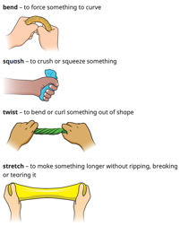  Working scientifically:  - Performing simple tests.  Enquiry type: comparative and fair testing.
Y3 | Forces and magnets.  To compare how things move on different surfaces.  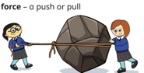  To notice that some forces need contact between two objects, but magnetic forces can act at a distance.  To observe how magnets attract or repel each other and attract some materials and not others.  To compare and group together a variety of everyday materials on the basis of whether they are attracted to a magnet and identify some magnetic materials.  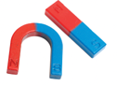  To describe magnets as having two poles.  To predict whether two magnets will attract or repel each other, depending on which poles are facing.  Working scientifically:  - Identifying differences, similarities or changes related to simple scientific ideas and processes.  - Using straightforward scientific evidence to answer questions or to support findings.  - Setting up simple practical, enquiries, comparative and fair tests,  - Using results to draw simple conclusions.  - Gathering, recording, classifying and presenting data in a variety of ways.  - Reporting on findings from enquiries, including oral and written explanations or presentations.  Enquiry type: comparative and fair testing (forces)    Enquiry type: pattern seeking (magnets) | Animals including humans.  To identify that animals, including humans, need the right types and amount of nutrition, and that they cannot make their own food; they get nutrition from what they eat.  To identify that humans and some other animals have skeletons and muscles for support, protection and movement.  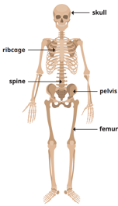  Working scientifically:  - Asking relevant questions and using different types of scientific enquiries to answer them.  - Recording findings using simple scientific language, drawings, labelled diagrams, keys, bar charts, and tables.  - Reporting on findings from enquiries, including oral and written explanations, displays or presentations of results and conclusions.  - Using straightforward scientific evidence to answer questions or to support their findings.  - Identifying differences, similarities or changes related to simple scientific ideas and processes.  Enquiry type: identifying, classifying and grouping. (skeletons)  Enquiry type: research using secondary sources (nutrition and diet) | Light  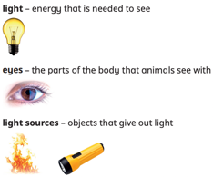  To recognise that they need light in order to see things and that dark is the absence of light.  To notice that light is reflected from surfaces.  To recognise that light from the sun can be dangerous and that there are ways to protect their eyes.  To recognise that shadows are formed when the light from a light source is blocked by an opaque object.  To find patterns in the way that the size of shadows change.  Working scientifically:  - Identifying differences, similarities or changes related to simple scientific ideas and processes.  - Recording findings using simple scientific language, drawings, labelled diagrams, keys, bar charts and tables.  - Gathering, recording, classifying and presenting data in a variety of ways to help in answering questions.  - Asking relevant questions and using different types of scientific enquiries to answer them.  - Setting up simple practical enquiries, comparative and fair tests.  Enquiry type: comparative and fair testing. |   Rocks  To compare and group together different kinds of rocks on the basis of their appearance and simple physical properties.  To describe in simple terms how fossils are formed when things that have lived are trapped within rock.  To recognise that soils are made from rocks and organic matter.  Working scientifically:  - Making systematic and careful observations and, where appropriate, taking accurate measurements using standard units, using a range of equipment, including thermometers and data loggers.  - Gathering, recording, classifying and presenting data in a variety of ways to help in answering questions.  - Asking relevant questions and using different types of scientific enquiries to answer them.  - Reporting on findings from enquiries, including oral and written explanations, displays or presentations of results and conclusions.  - Recording findings using simple scientific language drawings, labelled diagrams, keys, bar charts and tables.  - Using straightforward scientific evidence to answer questions or to support their findings.  - Setting up simple practical enquiries, comparative and fair tests.  Enquiry type: identifying, classifying and grouping. (rocks)  Enquiry type: research using secondary sources (fossils) |  | 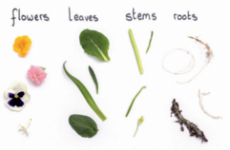  Plants  To identify and describe the functions of different parts of flowering plants: roots, stem/trunk, leaves and flowers.  To explore the requirements of plants for life and growth (air, light, water, nutrients from soil, and room to grow) and how they vary from plant to plant.  To investigate the way in which water is transported within plants.  To explore the part that flowers play in the life cycle of flowering plants, including pollination, seed formation and seed dispersal.  Working scientifically:  - Using straightforward scientific evidence to answer questions or to support their findings.  - Asking relevant questions and using different types of scientific enquiries to answer them.  - Setting up simple practical enquiries, comparative and fair tests.  - Identifying differences, similarities or changes related to simple scientific ideas and processes.  - Recording findings using simple scientific language, drawings, labelled diagrams, keys, bar charts, and tables.  - Reporting on findings from enquiries, including oral and written explanations, displays or presentations of results and conclusions.  - Using results to draw simple conclusions, make predictions for new values, suggest improvements and raise further questions.  Enquiry type: comparative and fair testing.    Enquiry type: observing over time.
Y4 | States of matter  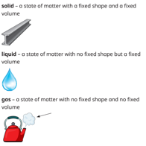  To compare and group materials together, according to whether they are solids, liquids or gases.  To observe that some materials change state when they are heated or cooled, and measure or research the temperature at which this happens in degrees Celsius.  To identify the part played by evaporation and condensation in the water cycle and associate the rate of evaporation with temperature.  Working scientifically:  - Identifying differences, similarities or changes related to simple scientific ideas.  - Asking relevant questions and using different types of scientific enquiries to answer them.  - Making systematic and careful observations and, where appropriate, taking accurate measurements using standard units, using a range of equipment, including thermometers and data loggers.  - Setting up simple practical enquiries, comparative and fair tests.  - Gathering, recording, classifying and presenting data in a variety of ways to help in answering questions.  - Using results to draw simple conclusions, make predictions for new values, suggest improvements and raise further questions.  Enquiry type: comparative and fair testing. |  | Sound  To identify how sounds are made, associating some of them with something vibrating.  To recognise that vibrations from sounds travel through a medium to the ear.  To find patterns between the pitch of a sound and features of the object that produced it.  To find patterns between the volume of a sound and the strength of the vibrations that produced it.  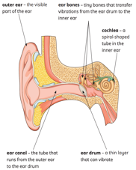  To recognise that sounds get fainter as the distance from the sound source increases.  Working scientifically:  - Asking relevant questions and using different types of scientific enquiries to answer them.  - Recording findings using simple scientific language, drawings, labelled diagrams, keys, bar charts and tables.  - Making systematic and careful observations and, where appropriate, taking accurate measurements using standard units, using a range of equipment, including thermometers and data loggers.  - Setting up simple practical enquiries, comparative and fair tests.  - Using results to draw simple conclusions.  Enquiry type: comparative and fair testing. | 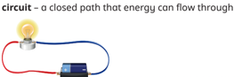  Electricity  To identify common appliances that run on electricity.  To construct a simple series electrical circuit, identifying and naming its basic parts, including cells, wires, bulbs, switches and buzzers.  To identify whether or not a lamp will light in a simple series circuit, based on whether or not the lamp is part of a complete loop with a battery.  To recognise that a switch opens and closes a circuit and associate this with whether or not a lamp lights in a simple series circuit.  To recognise some common conductors and insulators, and associate metals with being good conductors.  Working scientifically:  - Recording findings using simple scientific language, drawings, labelled diagrams, keys, bar charts and tables.  - Using results to draw simple conclusions, make predictions for new values, suggest improvements and raise further questions.  - Asking relevant questions and using different types of scientific enquiries to answer them.    Enquiry type: pattern seeking. | Animals including humans.  To describe the simple functions of the basic parts of the digestive system in humans.  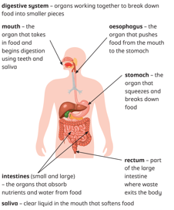  To identify the different types of teeth in humans and their simple functions.  To construct and interpret a variety of food chains, identifying producers, predators and prey.  Working scientifically:  - Identifying differences, similarities or changes related to simple scientific ideas and processes.  - Asking relevant questions and using different types of scientific enquiries to answer them.  - Setting up simple practical enquiries, comparative and fair tests.  - Reporting on findings from enquiries, including oral and written explanations, displays or presentations of results and conclusions.  - Using results to draw simple conclusions, make predictions for new values, suggest improvements and raise further questions.  Enquiry type: research using secondary sources |  | Living things and their habitats.  To recognise that living things can be grouped in a variety of ways.  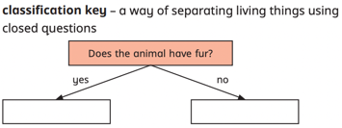  To explore and use classification keys to help group, identify and name a variety of living things in their local and wider environment.  To recognise that environments can change and that this can sometimes pose dangers to living things  Working scientifically:  - Asking relevant questions and using different types of scientific enquires to answer them.  - Gathering, recording, classifying and presenting data in a variety of ways to help in answering questions.  - Reporting on findings from enquiries, including oral and written explanations, displays or presentations of results and conclusions.  Enquiry type: identifying, classifying and grouping.
Y5 | Animals Including Humans  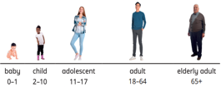  To describe the changes as humans develop to old age. (RSE link)  Working scientifically:  - Planning different types of scientific enquiries to answer questions, including recognising and controlling variables where necessary.  - Recording data and results of increasing complexity using scientific diagrams and labels, classification keys, tables, scatter graphs, bar and line graphs.  - Identify scientific evidence that has been used to support or refute ideas or arguments.  - Reporting and presenting findings from enquiries.    Enquiry type: Pattern seeking  Living things and their habitats  To describe the differences in the life cycles of a mammal, an amphibian, an insect and a bird.  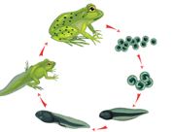  To describe the life process of reproduction in some plants and animals.  Working scientifically:  - Recording data and results of increasing complexity.  - Reporting and presenting findings from enquiries.  - Identifying scientific evidence that has been used to support or refute ideas or arguments.  Enquiry type: research using secondary sources. | Forces  To explain that unsupported objects fall towards the Earth because of the force of gravity acting between Earth and a falling object.  To identify the effects of air resistance, water resistance and friction, that act between moving surfaces.  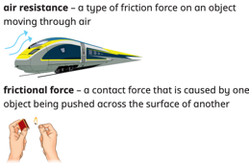  To recognise that some mechanisms, including levers, pulleys and gears, allow a smaller force to have a greater effect.  Working scientifically:  - Planning different types of scientific enquiries to answer questions, including recognising and controlling variables where necessary.  - Using a range of scientific equipment with increasing accuracy and precision.  - Reporting and presenting findings from enquiries.  - Taking measurements using a wide range of scientific equipment with increasing accuracy and precision, taking repeat readings when appropriate.  - Identifying scientific evidence that has been used to support or refute ideas or arguments.  Enquiry type: comparative and fair testing. | 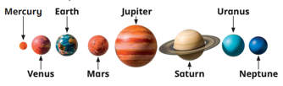  Earth and Space.  To describe the movement of the Earth and other planets, relative to the Sun and the solar system.  To describe the movement of the Moon relative to the Earth.  To describe the Sun, Earth and Moon as approximately spherical bodies.  To use the idea of the Earth’s rotation to explain day and night and the apparent movement of the sky.  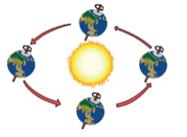  Working scientifically:  - Identifying scientific evidence that has been used to support or refute ideas or arguments.  - Reporting on findings from enquiries  - Recording data and results of increasing complexity  - Reporting and presenting findings from enquiries.  Enquiry type: research using secondary sources. | Properties of materials.  To compare and group together everyday materials on the basis of their properties, including their harness solubility, transparency, conductivity (electrical and thermal) and response to magnets.  Give reasons, based on evidence from comparative and fair tests, for the particular uses of everyday materials, including metals, wood and plastic.  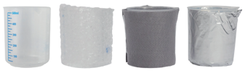  Working scientifically  - Recording data and results of increasing complexity.  - Planning different types of scientific enquiries to answer questions, including recognising and controlling variables where necessary.  - Taking measurements using a range of scientific equipment, with increasing accuracy and precision.  - Using test results to make predictions to set up further comparative and fair tests.  Enquiry type: comparative and fair testing. | Changes in materials.  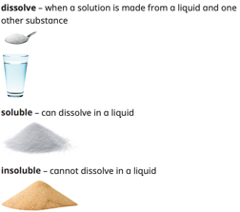  To know that some materials will dissolve in liquid to form a solution and describe how to recover a substance from a solution.  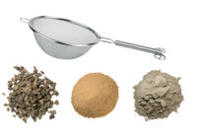  To use knowledge of solids, liquids and gases to describe how mixtures might be separated, including through filtering, sieving and evaporating.  To demonstrate that dissolving, mixing and changes of state are reversible changes.  To explain that some changes result in the formation of new materials, and that this kind of change is not usually reversible, including changes associated with burning and the action of acid on bicarbonate of soda.  Working scientifically:  - Using test results to make predictions to set up further comparative and fair tests.  - Recording data and results of increasing complexity using scientific diagrams and labels, classification keys, tables, bar and line graphs.  - Taking measurements, using a range of scientific equipment, with increasing accuracy and precision.  - Identifying scientific evidence that has been used to support or refute ideas or arguments.  Enquiry type: identifying, classifying and grouping.
Y6 |   Animals including humans: The circulatory system.  To identify and name the main parts of the human circulatory system, and describe the functions of the heart, blood vessels and blood.  To recognise the impact of diet, exercise, drugs and lifestyle on the way bodies function.  To describe the ways in which nutrients and water are transported within animals, including humans.  Working scientifically:  - Reporting and presenting findings from enquiries, including conclusions, causal relationships and explanations of and a degree of trust in results, in oral and written forms such as displays and other presentations.  - Identifying scientific evidence that has been used to support or refute ideas or arguments.  - Planning different types of scientific enquiries to answer questions, including recognising and controlling variables where necessary.  - Taking measurements, using a range of scientific equipment, with increasing accuracy and precision, taking repeat readings when appropriate.  - Using test results to make predictions to set up further comparative and fair tests.  Enquiry type: research. Using secondary sources (circulatory system).  Enquiry type: comparative and fair testing (diet and exercise). | Living things and their habitats: classification.  To describe how living things are classified into broad groups according to common observable characteristics and based on similarities and differences, including microorganisms, plants and animals.  To give reasons for classifying plants and animals based on specific characteristics.  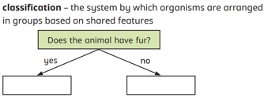  Working scientifically:  - Identifying scientific evidence that has been used to support or refute ideas or arguments.  - Reporting and presenting findings from enquiries, including conclusions, causal relationships and explanations of and a degree of trust in results, in oral and written forms such as displays and other presentations.  Enquiry type: identifying, classifying and grouping. | 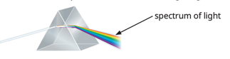  Light  To recognise that light appears to travel in straight lines.  To use the idea that light travels in straight lines to explain that objects are seen because they give out or reflect light into the eye.  To explain that we see things because light travels from light sources to our eyes or from light sources to objects and then to our eyes.  To use the idea that light travels in straight lines to explain why shadows have the same shape as the objects that cast them.  Working scientifically:  - Recording data and results of increasing complexity using scientific diagrams and labels, classification keys, tables, scatter graphs, bar and line graphs.  - Planning different types of scientific enquiries to answer questions, including recognising and controlling variables where necessary.  - Taking measurements, using a range of scientific equipment, with increasing accuracy and precision, taking repeat readings when appropriate  - Identifying scientific evidence that has been used to support or refute ideas or arguments.  Enquiry type: comparative and fair testing. | Electricity  To associate the brightness of a lamp or the volume of a buzzer with the number and voltage of cells used in the circuit.  To compare and give reasons for variations in how components function, including the brightness of bulbs, the loudness of buzzers and the on/off position of switches.  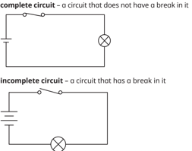  To use recognised symbols when representing a simple circuit in a diagram.  Working scientifically:  - Recording data and results of increasing complexity using scientific diagrams and labels, classification keys, tables, scatter graphs, bar and line graphs.  - Reporting and presenting findings from enquiries, including conclusions, causal relationships and explanations of and a degree of trust in results, in oral and written forms such as displays and other presentations.  - Planning different types of scientific enquiries to answer questions, including recognising and controlling variables where necessary.  - Taking measurements, using a range of scientific equipment, with increasing accuracy and precision, taking repeat readings when appropriate.  - Using test results to make predictions to set up further comparative and fair tests.  Enquiry type: comparative and fair testing. |  |  |   Evolution  Recognise that living things have changed over time and that fossils provide information about living things that inhabited the Earth millions of years ago.  Recognise that living things produce offspring of the same kind, but normally offspring vary and are not identical to their parents.  Identify how animals and plants are adapted to suit their environment in different ways and that adaptation may lead to evolution.  Working scientifically:  - Identifying scientific evidence that has been used to support or refute ideas or arguments.  - Reporting and presenting findings from enquiries, including conclusions, causal relationships and explanations of and a degree of trust in results, in oral and written forms such as displays and other presentations.  - Recording data and results of increasing complexity, using scientific diagrams and labels, classification keys, tables, scatter graphs, bar charts and line graphs.    Enquiry type: pattern seeking.  Enquiry type: research using secondary sources.

