English 2026- 2027
 | Autumn 1 | Autumn 2 | Spring 1 | Spring 2 | Summer 1 | Summer 2
EYFS
Y1 | 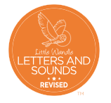  Spelling:  Little Wandle | Spelling:  Little Wandle | Spelling:  Little Wandle | Spelling:  Little Wandle | Spelling:  Little Wandle | Spelling:  Little Wandle
Y1 | Handwriting:  Yr 1 Nelson Handwriting units 1 – 4 | Handwriting:  Yr 1 Nelson Handwriting units 5 – 8 | Handwriting:  Yr 1 Nelson Handwriting units 9 – 12 | Handwriting:  Yr 1 Nelson Handwriting units 13 – 17 | Handwriting:  Yr 1 Nelson Handwriting units 18 – 23 | Handwriting:  Yr 1 Nelson Handwriting units 24 – 28
Y1 | Reading:  Little Wandle | Reading:  Little Wandle | Reading:  Little Wandle | Reading:  Little Wandle | Reading:  Little Wandle | Reading:  Little Wandle
Y1 | Writing:  So much  Recount: Oi frog  Recount: Letter  The tiger who came to tea  Instructions: Making a sandwich | Writing:  Story narrative: The little red hen  Non chronological report:  Animals  Recount | Writing:  Letter: Beegu  Non chronological report:  Space  Story narrative:  Man on the moon | Writing:  Story narrative: character description:  The Gingerbread man  Story narrative:  Jack and the Beanstalk  Instructions:  Planting a beanstalk | Writing:  Story narrative:  Goldilocks and the three bears  Letter:  The three little pigs | Writing:  Letter writing:  The snail and the whale  Non chronological report: Settings- beach, forest, town, city  Personal recount
Y2 |   Spelling:  Little Wandle Phase 5 Review | Spelling:  Little Wandle Bridge to spelling programme | Spelling:  Little Wandle  Unit 1 - 3 | Spelling:  Little Wandle  Unit 4 - 7 | Spelling:  Little Wandle  Unit 8 - 11 | Spelling:  Little Wandle  Unit 12 - 14
Y2 | Handwriting:  Yr 2 Nelson Handwriting units 1 – 5 | Handwriting:  Yr 2 Nelson Handwriting units 6 – 10 | Handwriting:  Yr 2 Nelson Handwriting units 11 – 14 | Handwriting:  Yr 2 Nelson Handwriting units 15 – 18 | Handwriting:  Yr 2 Nelson Handwriting units 19 – 23 | Handwriting:  Yr 2 Nelson Handwriting units 24 – 28
Y2 | Reading:  The Smartest Giant in Town  There’s no Dragon in this story  Bold Women in Black History | Reading:  The Last Wolf  Vlad and the Great Fire of London  The Village Green  The Bog Baby | Reading:  Voices in the Park  The Dot | Reading:  Horton Hears a who  Meerkat Mail  Inference from pictures | Reading:  How to wash a woolly mammoth  Opening worlds booklets: The Stone Age | 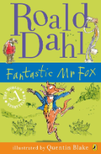  Reading:  Fantastic Mr Fox
Y2 | Writing:  Narrative: Duffy The Runaway Train  Recount  Letter: Fire safety  Diamante Poem | Writing:  Diary writing: Samuel Pepys  Narrative  Fact File: Gladys Alward | Writing:  Narrative: Setting description: The Black Hat  Book Review: The Black Hat  Instructions: Making soup | Writing:  Narrative: Katie in London  Brochure: London and its landmarks | Writing:  Non chronological report: Woolly Mammoths  Poetry  Narrative: Stone Age Boy | Writing:  Diary writing: Smeds and the Smoods  Recount: Sports Day  Review of year 2
Y3 |   Spelling:  No Nonsense Spelling  Yr 3 Block 1 | Spelling:  No Nonsense Spelling  Yr 3 Block 2 | Spelling:  No Nonsense Spelling  Yr 3 Block 3 | Spelling:  No Nonsense Spelling  Yr 3 Block 4 | Spelling:  No Nonsense Spelling  Yr 3 Block 5 | Spelling:  No Nonsense Spelling  Yr 3 Block 6
Y3 | Handwriting:  Yr 3 Nelson Handwriting units 1 – 5 | Handwriting:  Yr 3 Nelson Handwriting units 6 – 10 | Handwriting:  Yr 3 Nelson Handwriting units 11 – 14 | Handwriting:  Yr 3 Nelson Handwriting units 15 – 18 | Handwriting:  Yr 3 Nelson Handwriting units 19 – 23 | Handwriting:  Yr 3 Nelson Handwriting units 24 – 28
Y3 | Reading:  Anisha Accidental Detective Serena Patel  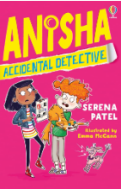 | Reading:  Anisha Accidental Detective Serena Patel | Reading:  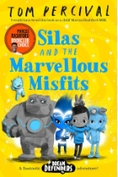  Silas and the Marvellous Misfits Tom Percival | Reading:  Silas and the Marvellous Misfits Tom Percival | Reading:  The Creakers Tom Fletcher  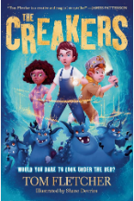 | Reading:  The Creakers Tom Fletcher
Y3 | Writing:  Diary writing: Howard Carter  Narrative recounts: Egyptian Myths | Writing:  Persuasive writing: Extra playtime  Narrative: The Lighthouse  (setting and character)  Instruction writing | 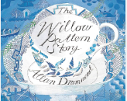  Writing:  The Willow Pattern  Narrative:  Setting descriptions  Dialogue  Letters | 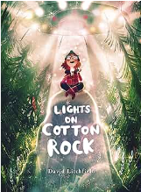  Writing:  Explanation texts  Narrative: Lights on Cotton Rock (description and figurative language) | 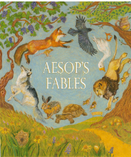  Writing:  Aesop’s fables: Fiction  Non Chronological report | Writing:  Greek myths  Newspaper report  Poetry – limericks
Y4 | Spelling:  No Nonsense Spelling  Yr 3 Block 1 | Spelling:  No Nonsense Spelling  Yr 3 Block 2 | Spelling:  No Nonsense Spelling  Yr 3 Block 3 | Spelling:  No Nonsense Spelling  Yr 3 Block 4 | Spelling:  No Nonsense Spelling  Yr 3 Block 5 | Spelling:  No Nonsense Spelling  Yr 3 Block 6
Y4 | Handwriting:  Yr 4 Nelson Handwriting units 1 – 5 | Handwriting:  Yr 4 Nelson Handwriting units 6 – 10 | Handwriting:  Yr 4 Nelson Handwriting units 11 – 14 | Handwriting:  Yr 4 Nelson Handwriting units 15 – 18 | Handwriting:  Yr 4 Nelson Handwriting units 19 – 23 | Handwriting:  Yr 4 Nelson Handwriting units 24 – 28
Y4 | Reading:  James and The Giant Peach Roald Dahl  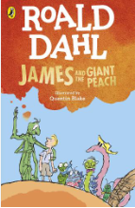 | Reading:  The Lion, the Witch and the Wardrobe C S Lewis  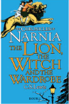 | Reading:  The Lion, the Witch and the Wardrobe C S Lewis | Reading:  Sleeping Beauty –Fairy Tales  Creeping Beauty Joseph Coelho  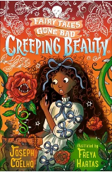 | Reading:  The Boy in the back of the class Onjali Q Rauf  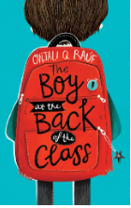 | Reading:  The Boy in the back of the class Onjali Q Rauf
Y4 | 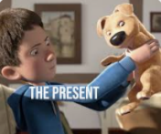  Writing:  The Present:  Diary writing  Narrative  Balanced argument | Writing:  The Lion, the Witch and the Wardrobe:  Narrative: Setting description  Informal letters  Poetry | 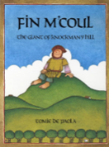  Writing:  Finn Macoul:  Narrative: Character description  Dialogue  Persuasive writing | Writing:  Explanation  Narrative | 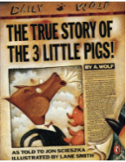  Writing:  Narrative: Twisted fairy tales  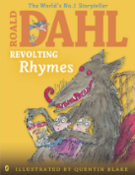  Play scripts  Poetry (Roald Dahl Revolting Rhymes) | Writing:  Newspaper articles  Narrative
Y5 | Spelling:  No Nonsense Spelling  Yr 5 Block 1 | Spelling:  No Nonsense Spelling  Yr 5 Block 2 | Spelling:  No Nonsense Spelling  Yr 5 Block 3 | Spelling:  No Nonsense Spelling  Yr 5 Block 4 | Spelling:  No Nonsense Spelling  Yr 5 Block 5 | Spelling:  No Nonsense Spelling  Yr 5 Block 6
Recovery:  Yr 5 catch up programme | Handwriting:  Yr 3 Nelson Handwriting units 1 – 5 | Handwriting:  Yr 3 Nelson Handwriting units 6 – 10 | Handwriting:  Yr 3 Nelson Handwriting units 11 – 14 | Handwriting:  Yr 3 Nelson Handwriting units 15 – 18 | Handwriting:  Yr 3 Nelson Handwriting units 19 – 23 | Handwriting:  Yr 3 Nelson Handwriting units 24 – 28
 | Reading:  Hacker Malorie Blackman 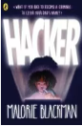 | Reading:  The Explorer Katherine Rundell  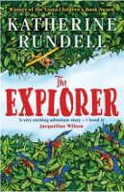 | Reading:  The Shape of Rainbows Neal Zetter  William Shakespeare: Romeo and Juliet  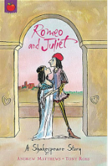 | Reading:  The girl who stole an elephant Nizrana Farook  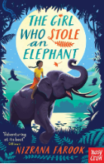 | Reading:  The girl who stole an elephant Nizrana Farook | Reading:  Peter Pan J M Barrie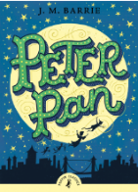  The Highway man  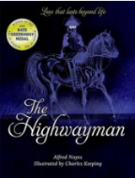
 | Writing:  Letters:  Formal and informal  Narrative: Harriet Tubman  Newspaper report | Writing:  Narrative:  Dialogue to move a story on  Non chronological report: There’s a Rang Tan in my Bedroom | Writing:  Play scripts  Diary entries  Biography | Writing:  Descriptive writing (within narrative) | Writing:  Narrative  Instructions | 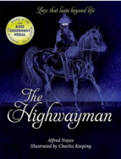  Writing:  Poetry: The Highway man  Letters: Informal
Y6 | Spelling:  No Nonsense Spelling  Yr 6 Block 1 | Spelling:  No Nonsense Spelling  Yr 6 Block 2 | Spelling:  No Nonsense Spelling  Yr 6 Block 3 | Spelling:  No Nonsense Spelling  Yr 6 Block 4 | Spelling:  No Nonsense Spelling  Yr 6 Block 5 | Spelling:  No Nonsense Spelling  Yr 6 Block 6
Recovery:  Yr 6 catch up programme | Handwriting:  Yr 4 Nelson Handwriting units 1 – 5 | Handwriting:  Yr 4 Nelson Handwriting units 6 – 10 | Handwriting:  Yr 4 Nelson Handwriting units 11 – 14 | Handwriting:  Yr 4 Nelson Handwriting units 15 – 18 | Handwriting:  Yr 4 Nelson Handwriting units 19 – 23 | Handwriting:  Yr 4 Nelson Handwriting units 24 – 28
 | Reading:  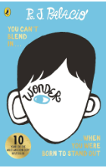  Wonder | Reading:  Harry Potter and the Philosopher’s stone  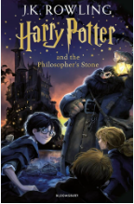 | Reading:  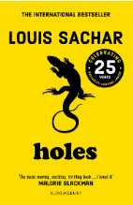  Holes Louis Sachar | Reading:  Holes Louis Sachar | Reading:  SATS Practice | Reading:  The Final year Matt Goodfellow  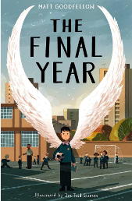
 | Writing:  Poetry  Diary entries  Balanced arguments | Writing:  Narrative – setting and character descriptions  Non Chronological reports | Writing:  Eye witness reports  Newspaper reports  Narrative – using dialogue to move the story on | Writing:  Narrative – Animation unit (The piano)  Formal and informal letters | Writing:  Narrative – Animation unit (Alma): suspense writing  Explanation writing (The circulatory system) | Writing:  Persuasive arguments  Poetry

